**Experiment 28**

**Digital Electronics with Altera**

**Part II: The Practical Part**

**Use this document as a template for your submission.**

**This document refers to questions and problems in Sections 2, 3 and 4 in the Experiment 28 Lab Script.**

**You must write a comment/explanation wherever this heading is given below. Credit for comments/explanations forms part of the awardable marks.**

|  |
| --- |
| **I confirm that I have read and understood the University’s definitions of plagiarism and collusion from the Code of Practice on Assessment. I confirm that I have neither committed plagiarism in the completion of this work nor have I colluded with any other party in the preparation and production of this work. The work presented here is my own and in my own words except where I have clearly indicated and acknowledged that I have quoted or used figures from published or unpublished sources (including the web). I understand the consequences of engaging in plagiarism and collusion as described in the Code of Practice on Assessment (Appendix L).** |

|  |
| --- |
| **Important:** Marking of all coursework is anonymous. Do not include your name, student ID number, group number, email or any other personal information in your report or in the name of the file submitted via Canvas. A penalty will be applied to submissions that do not meet this requirement. |

**Section 2. Project Design based on Schematic Capture [14 Marks]**

**Tip 1: you must write a comment/explanation whenever prompted below by the words ‘Comment/Explanation’. You will sometimes also find guidance about this in the main script, but just because the main script doesn’t mention a comment/explanation, or you don’t think it is warranted, does not mean that you shouldn’t write one.**

**Tip 2: In some of the more advanced sections below, it’s understandable that some of you may find it more convenient, very occasionally, to screen-grab more than one simulation, or split a single simulation up into several figures in which you zoom in on several parts within the Quartus II Simulation Waveform Editor. This is not a problem, but please keep it within sensible limits.**

**Tip 3: Get through Section 2 as quickly as you can to allow you enough time for 3 & 4.**

**Tip 4: You will need to provide photos of your programming of the DE1 board, whenever you were instructed to program the board in the main script (twice in Section 2 and three times in Section 3.) Below, at the end of each of these sections, a space is devoted to allow you to paste your photos. Don’t go mad – 2 or 3 photos will do for each programming of the board. Take your photographs strategically so that they show off the new functionality for each new programming.**

**Section 2.3 Drawing Your Schematic [3 Marks]**

The schematic, including the compilation result.

*Focused screenshot:*

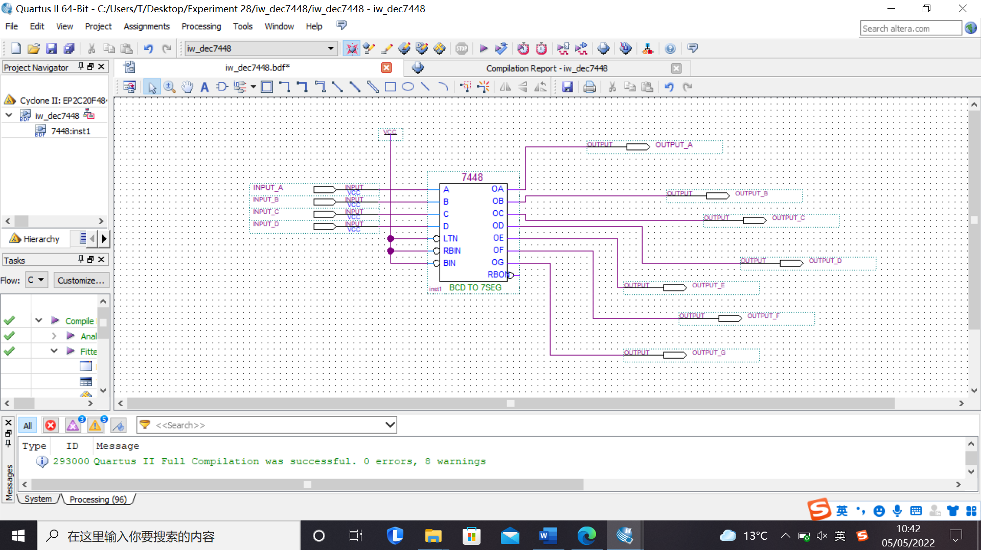

*Figure 1: Schematic Circuit*

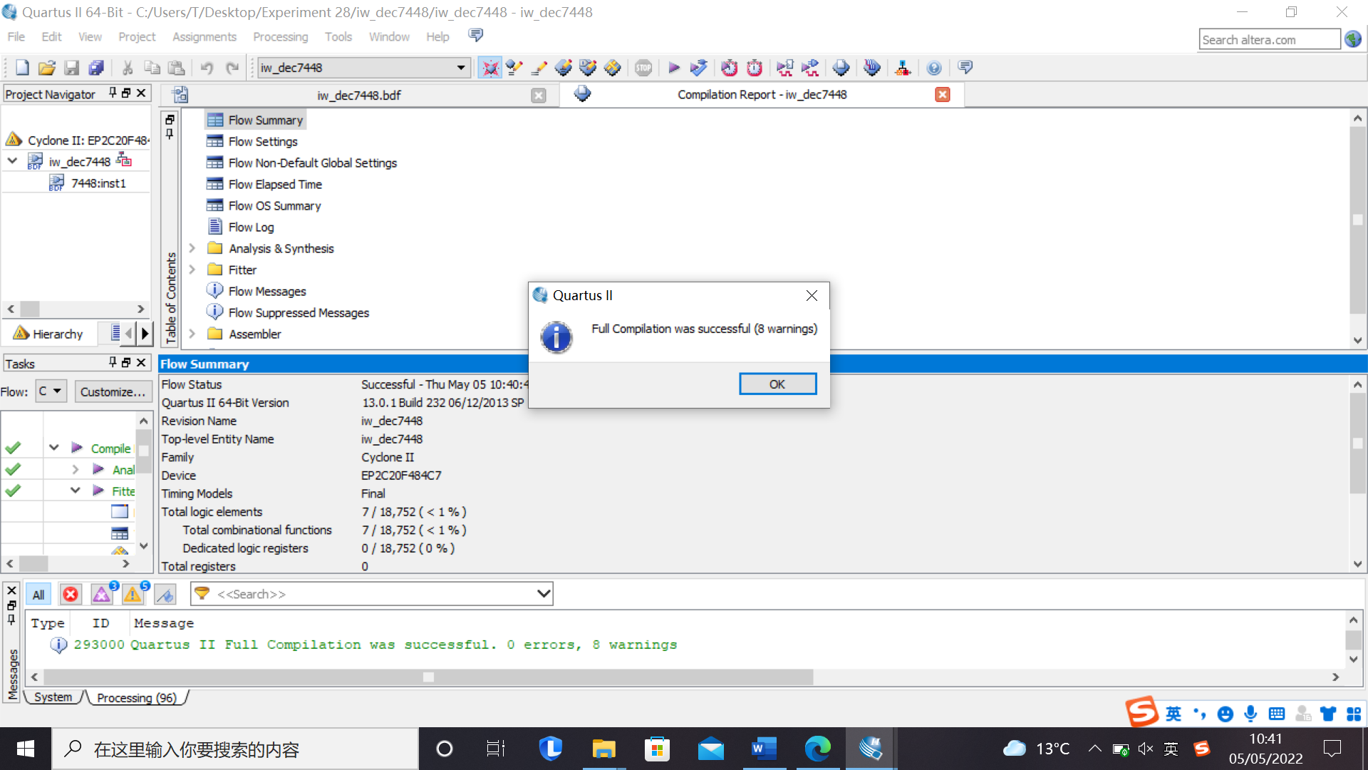

*Figure 2: Compilation successful*

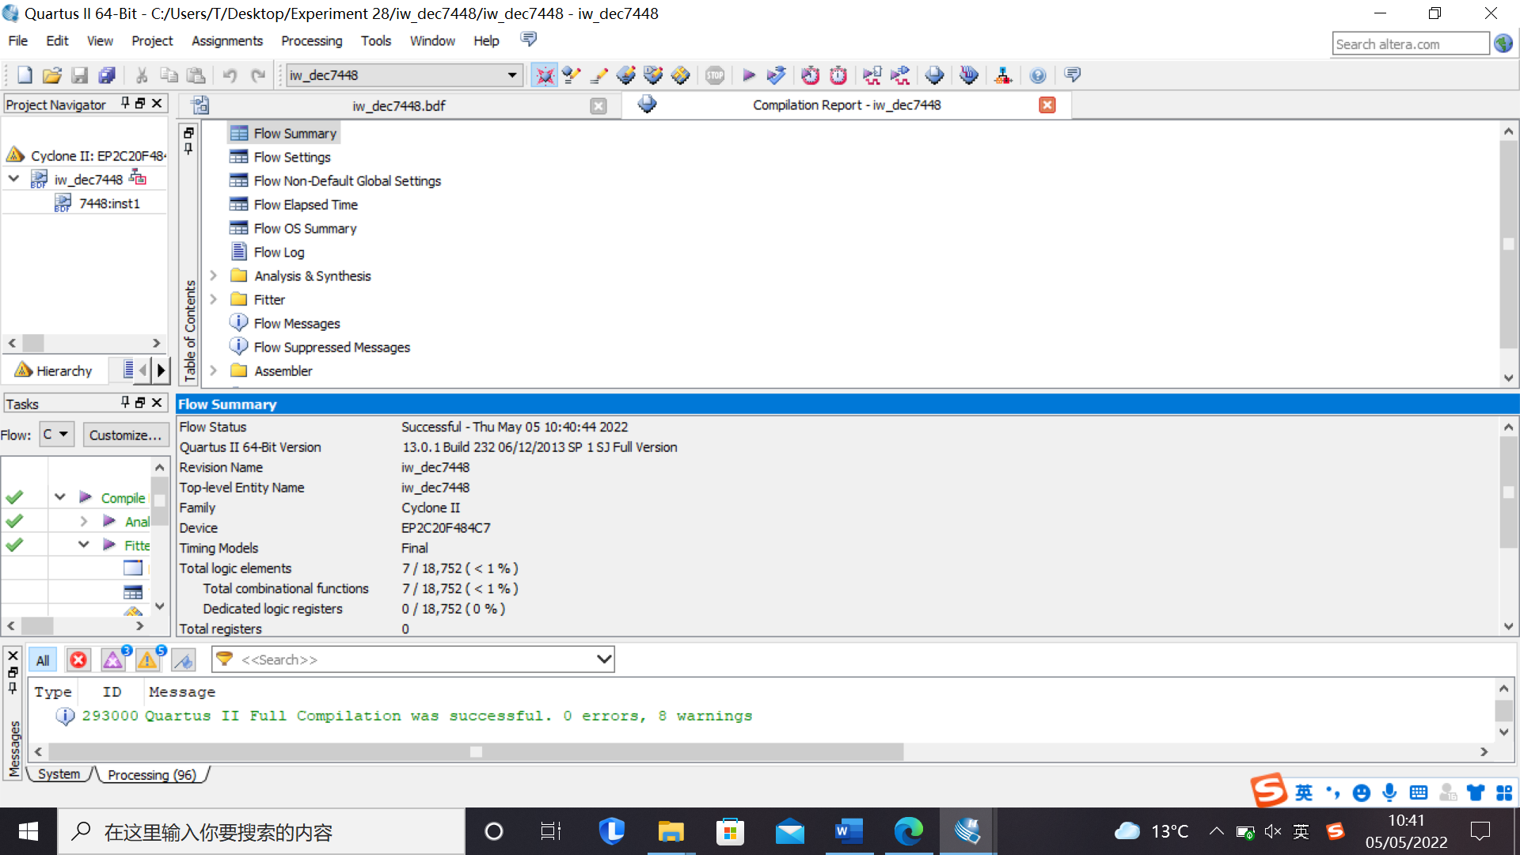

*Figure 3: report*

*Comment/Explanation:*

Figure 1 shows the schematic diagram for the 7448. Figure 2 and 3 shows that the compilation is successful and details of the circuit.

**Section 2.4 Waveform Entry for Simulation [3 Marks]**

The output simulation waveform.

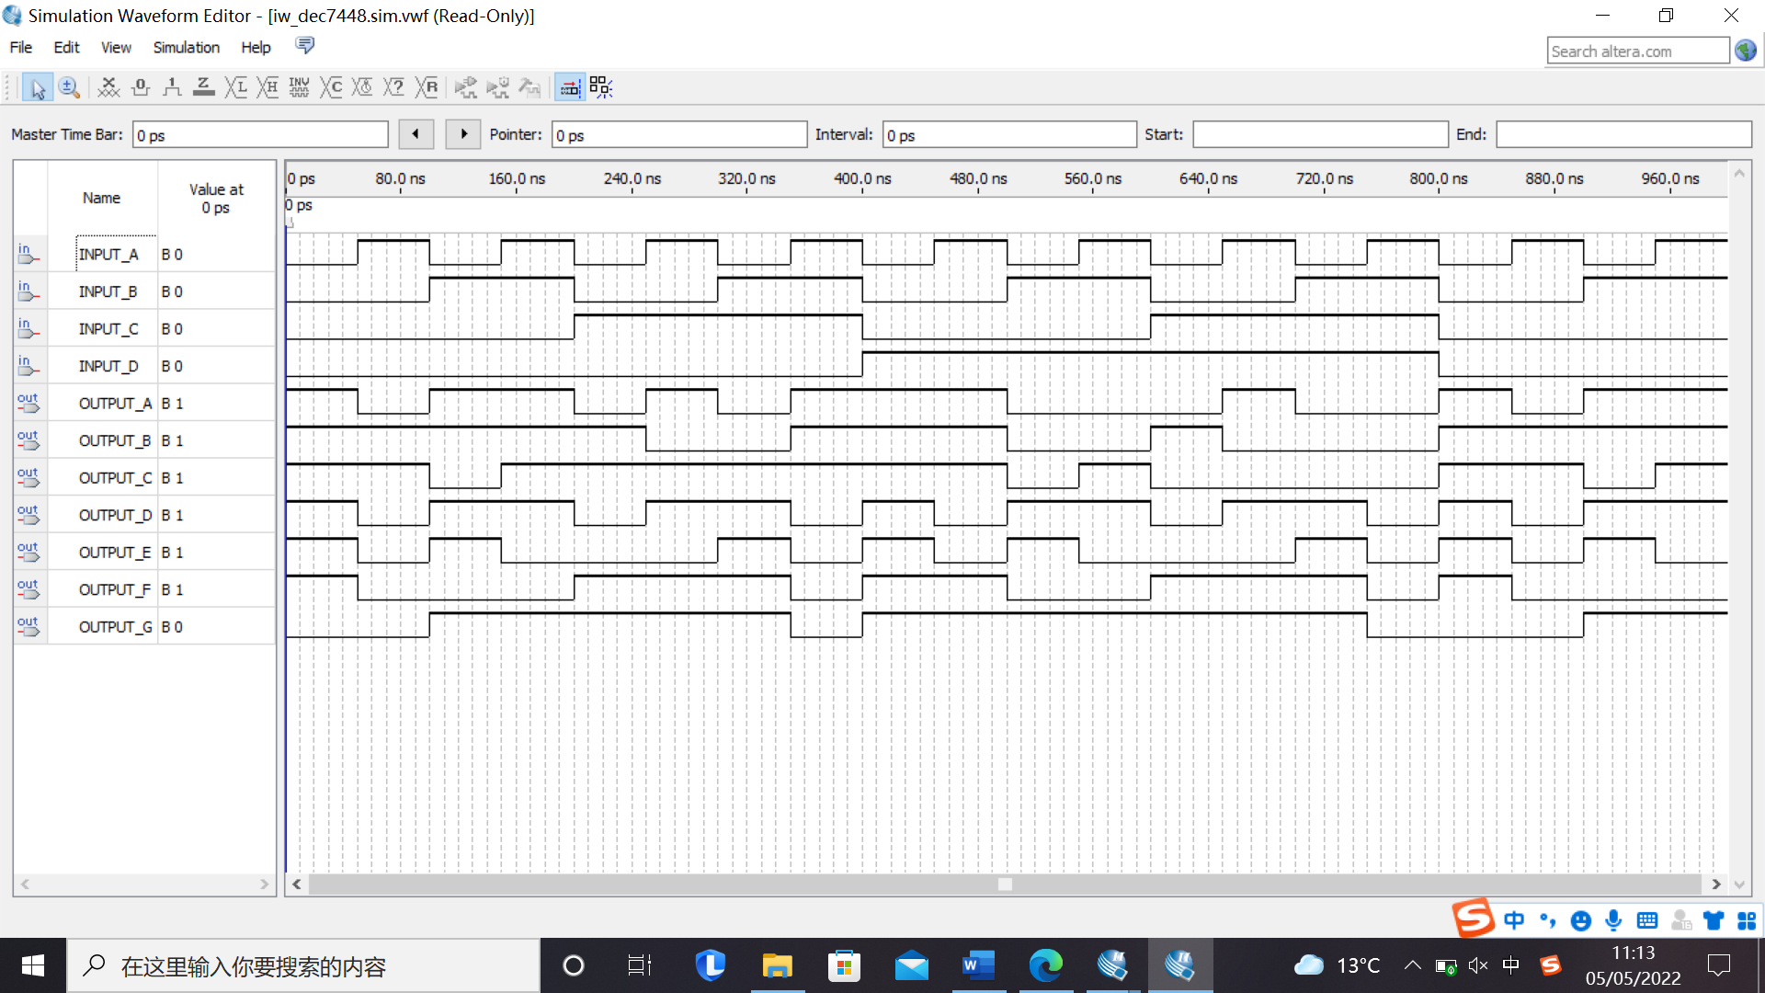*Focused screenshot:*

*Figure 4: Output waveform*

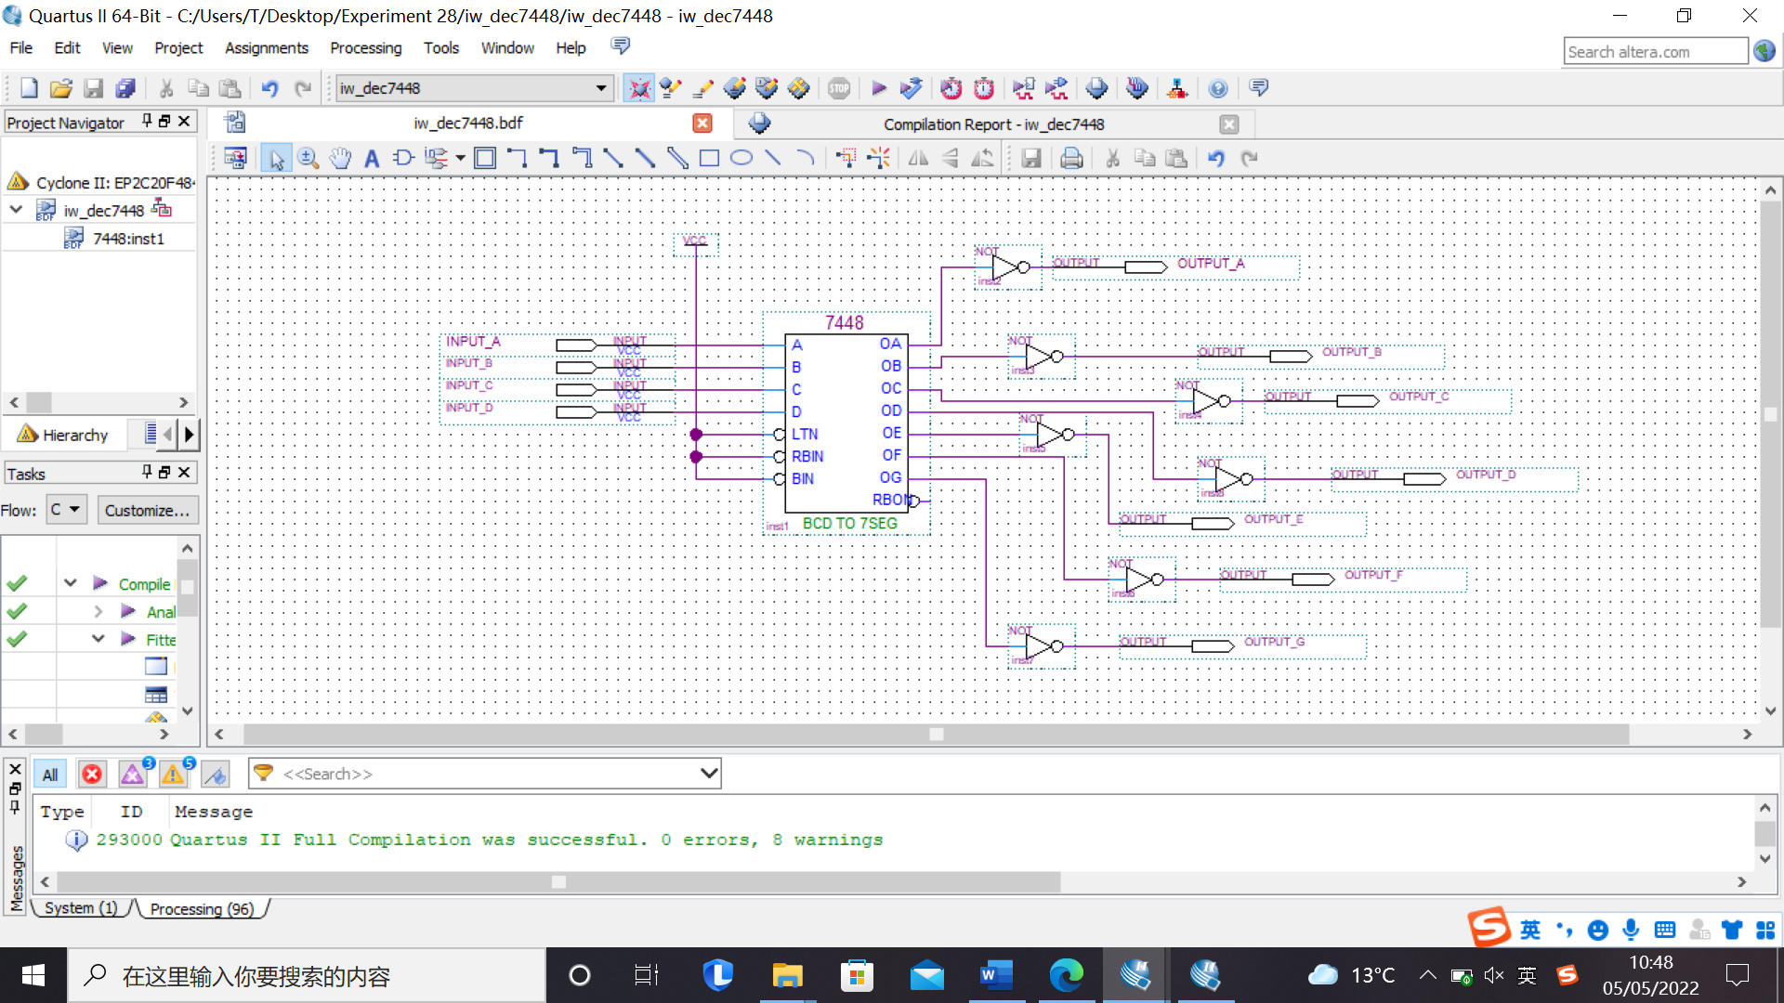

*Figure 5: Schematic (with inverter)*

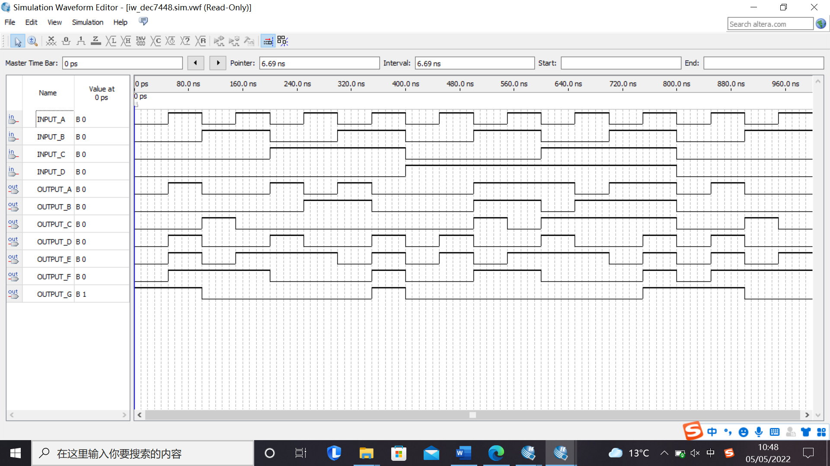

*Figure 6: Output waveform (with inverter)*

*Comment/Explanation:*

From Figure 4, it can be seen that the period for Input A, B, C, D are 100ns, 200ns, 400ns and 800ns.

By analysing the output result in Figure 4, it can be found that it is a 7-segment decoder.

|  |  |  |  |  |  |  |  |  |  |  |  |
| --- | --- | --- | --- | --- | --- | --- | --- | --- | --- | --- | --- |
| Input | | | | Output | | | | | | | |
| I0 | I1 | I2 | I3 | a | b | c | d | e | f | g |
| 0 | 0 | 0 | 0 | 1 | 1 | 1 | 1 | 1 | 1 | 0 |
| 0 | 0 | 0 | 1 | 0 | 1 | 1 | 0 | 0 | 0 | 0 |
| 0 | 0 | 1 | 0 | 1 | 1 | 0 | 1 | 1 | 0 | 1 |
| 0 | 0 | 1 | 1 | 1 | 1 | 1 | 1 | 0 | 0 | 1 |
| 0 | 1 | 0 | 0 | 0 | 1 | 1 | 0 | 0 | 1 | 1 |
| 0 | 1 | 0 | 1 | 1 | 0 | 1 | 1 | 0 | 1 | 1 |
| 0 | 1 | 1 | 0 | 1 | 0 | 1 | 1 | 1 | 1 | 1 |
| 0 | 1 | 1 | 1 | 1 | 1 | 1 | 0 | 0 | 0 | 0 |
| 1 | 0 | 0 | 0 | 1 | 1 | 1 | 1 | 1 | 1 | 1 |
| 1 | 0 | 0 | 1 | 1 | 1 | 1 | 1 | 0 | 1 | 1 |
| 1 | 0 | 1 | 0 | 1 | 1 | 1 | 0 | 1 | 1 | 1 |
| 1 | 0 | 1 | 1 | 0 | 0 | 1 | 1 | 1 | 1 | 1 |
| 1 | 1 | 0 | 0 | 1 | 0 | 0 | 1 | 1 | 1 | 0 |
| 1 | 1 | 0 | 1 | 0 | 1 | 1 | 1 | 1 | 0 | 1 |
| 1 | 1 | 1 | 0 | 1 | 0 | 0 | 1 | 1 | 1 | 1 |
| 1 | 1 | 1 | 1 | 1 | 0 | 0 | 0 | 1 | 1 | 1 |

Since the segment LEDs are active low, inverters are required at the output. The result can be seen in Figure 5 and Figure 6.

**Section 2.5 Design Project based on Verilog Code: Decoder [4 Marks]**

The schematic (with pin allocations) *YI_7SegmentDecoder.bdf*

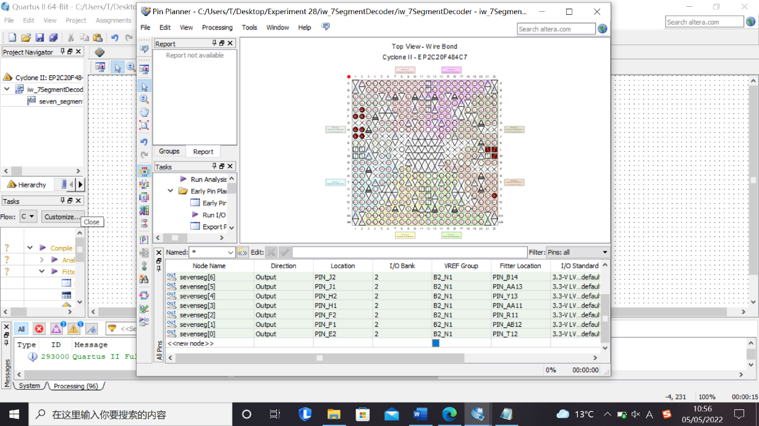*Focused screenshot:*

*Figure 7:* *Pin Planner*

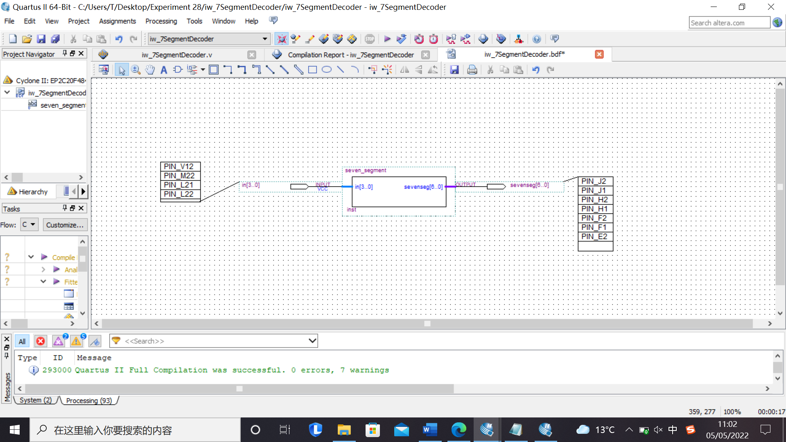

*Figure 8: Schematic*

*Comment/Explanation:*

It can be seen that verilog can be used to create circuit as we want. What is more, we can also use pin planner to allow the circuit to connect with the FPGA board. In order to achieve the segment LEDS are active low, an inverter is required at the output.

**Section 2.6 Input Simulation for Decoder [4 Marks]**

The simulation waveform

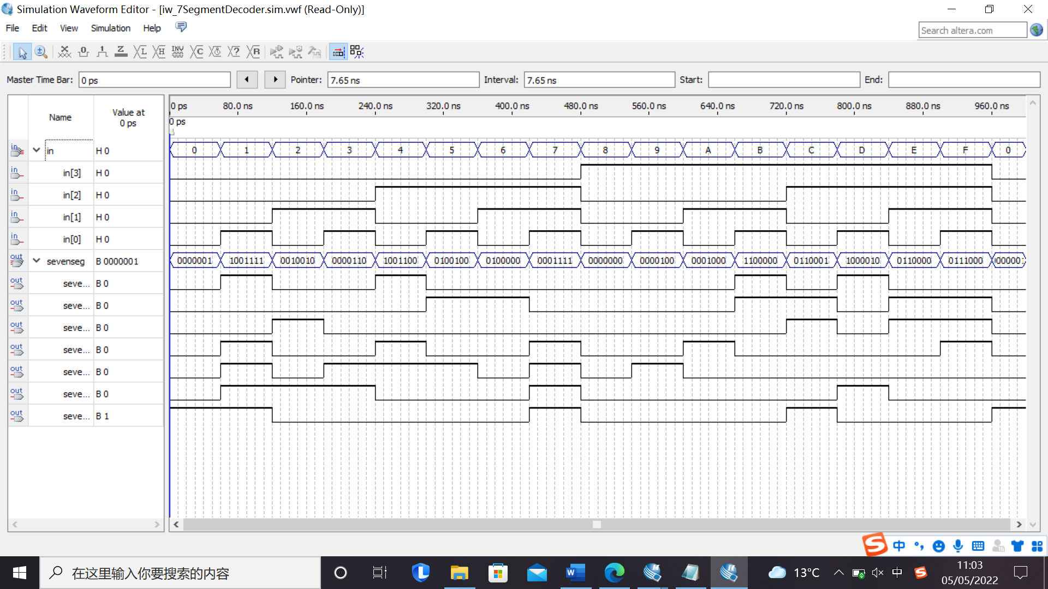*Focused screenshot:*

*Figure 9: Simulation waveform*

*Comment/Explanation:*

By analysing the waveform, it can be seen that 4 input consists of a hexadecimal value, and the output value is same as the Verilog file contents. It can be seen that the all the outputs are inverted compare to the first waveform in Section 2.4. That is because the segment LEDs are active low. Therefore, we deigned the Verilog file according to this rule.

**Photos of operation on the board**

Use this space to insert photographs of the DE1 board’s operation in the lab for the **two** parts of Section 2 of the script that instructed you to program the board.(You run the risk that some marks will be deducted from this section if such photographs are not included.)

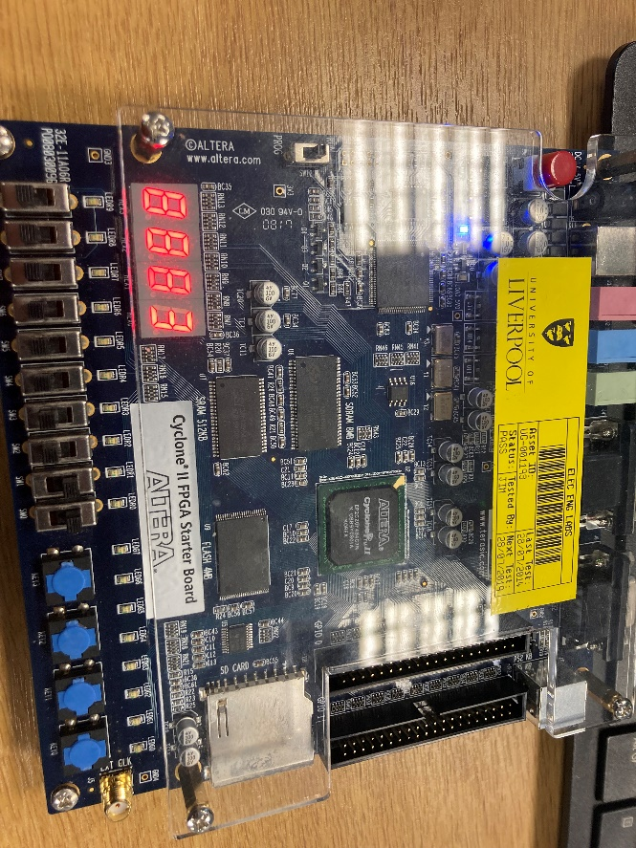

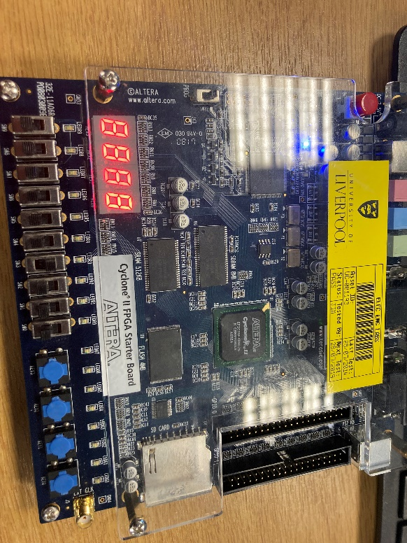

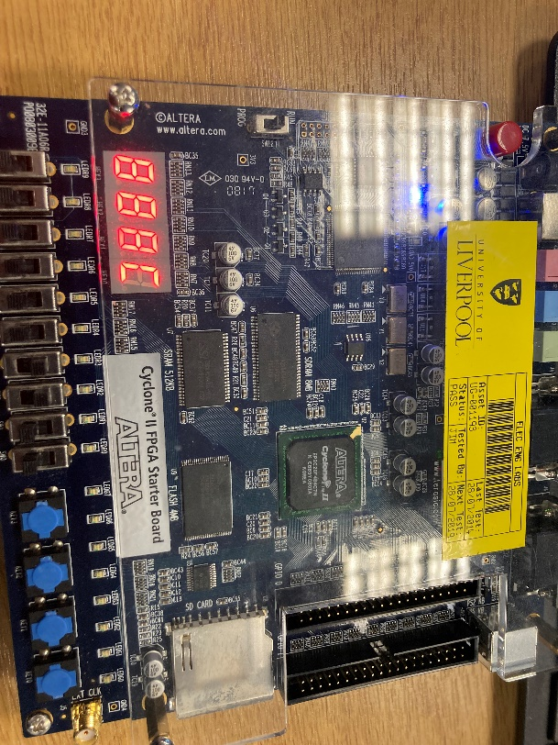

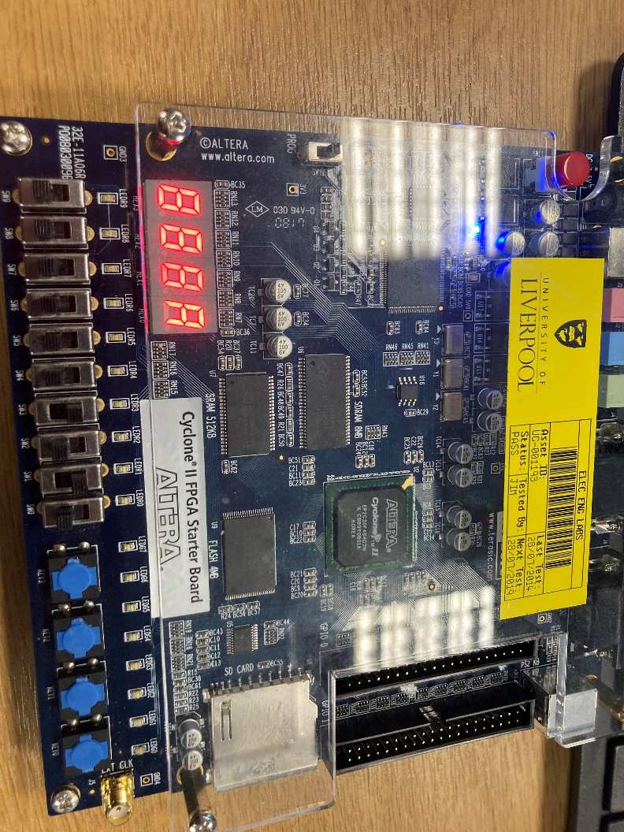

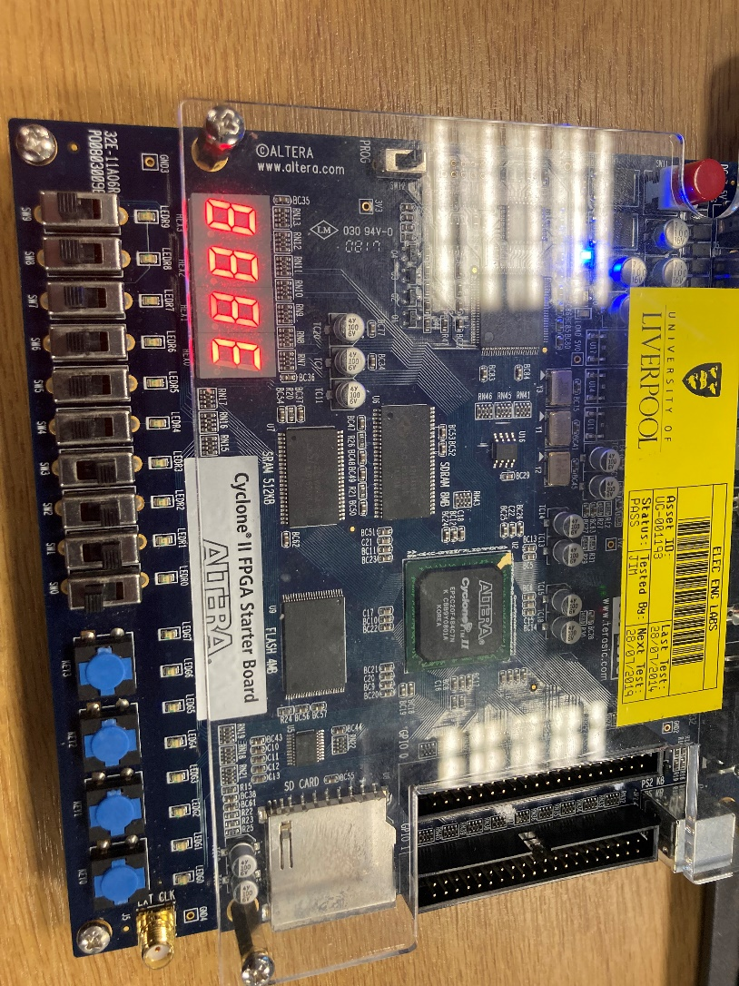

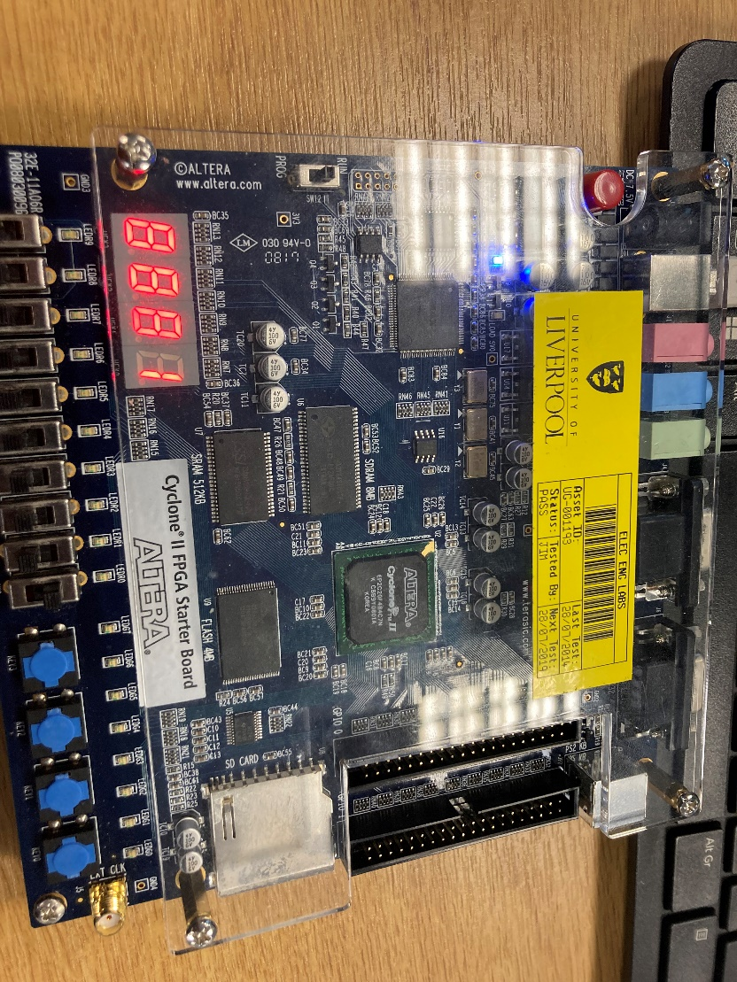

**See below for Section 3.**

**Section 3. Sequential design in Verilog [26 Marks]**

**Section 3.1 Counter design in Verilog [8 marks]**

Both schematics  **[4 Marks]**

*Decade counter – focused screenshot:*

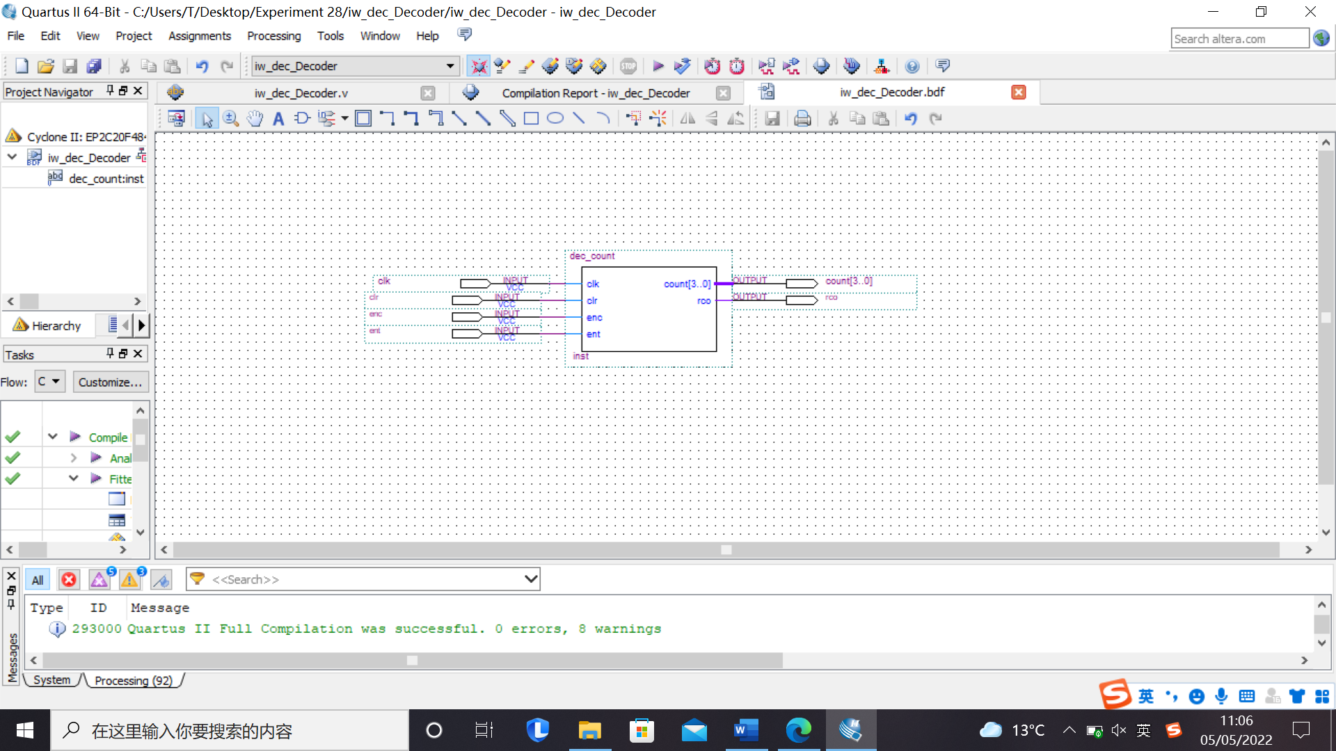

*Figure 10: Schematic result*

*Comment/Explanation:*

This is the diagram for a Counter counting from 0 to 9. It has four inputs and 2 outputs.

“rco” will go to HIGH when the counter counts to the maximum number.

*Decade counter with 7-segment decoder – focused screenshot:*

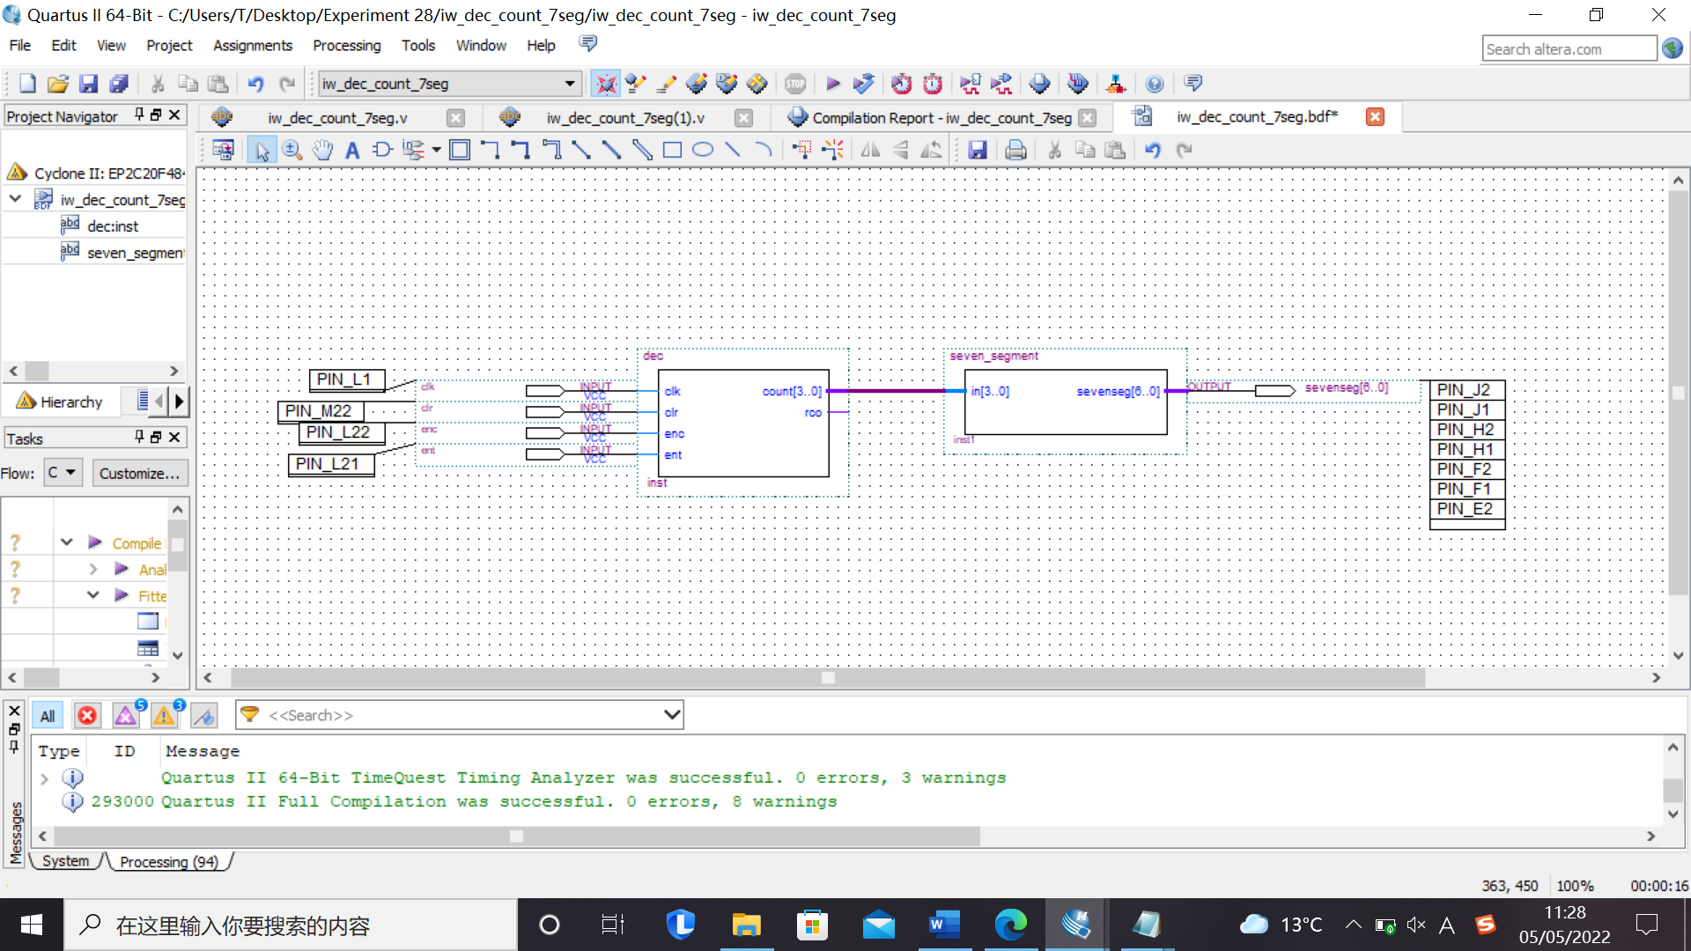

*Figure 11: Schematic result*

*Comment/Explanation:*

By connecting the decoder and seven segment together, the number can be seen on the board. That is easy way for us to see the output numbers.

Both simulation waveforms **[4 Marks]**

*Simulation of counter – focused screenshot:*

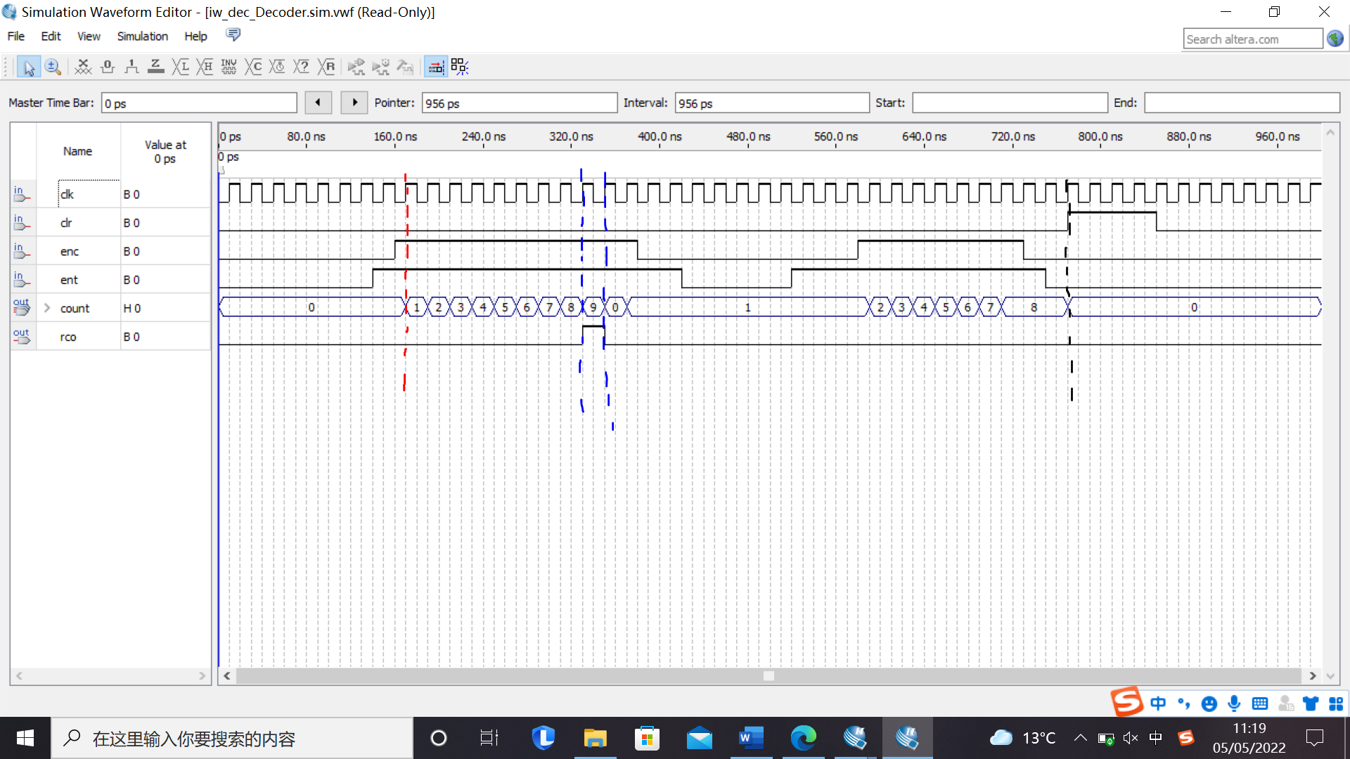

*Figure 12: Simulation result*

*Simulation of counter connected to 7-segment decoder – focused screenshot:*

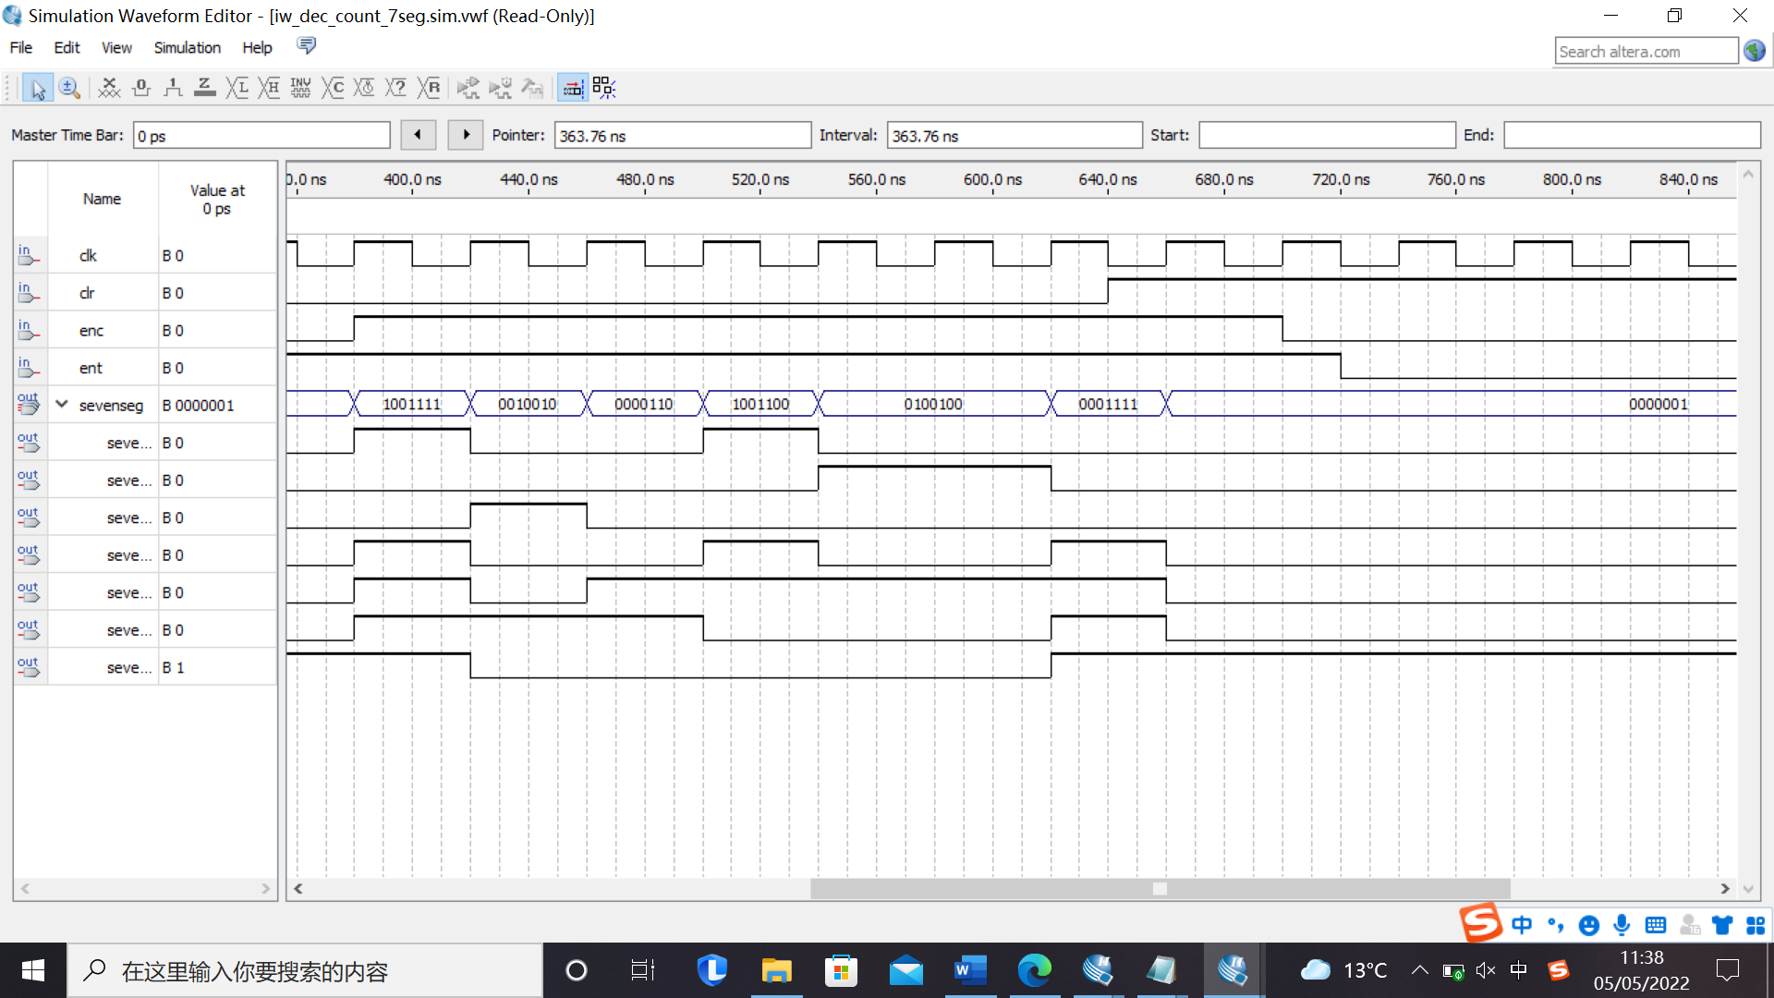

*Figure 13: Simulation result*

*Comment/Explanation for both:*

**From Figure 12:**

It is proved that this circuit is a counter. When both enc and ent are HIGH, the counter starts to count number at the raising edge of the clock cycle. (see red line). If one of the enc or ent is low, the counter will not count number from the rising edge of the clock cycle.

When the counter is ready to count number 9, the rco will set to 1 at the raising edge of the clock cycle, while the counter output number 9 at the same time. (see blue line). After that, the rco will reset to 0 and the counter count number 0. That means the beginning of a new counter cycle.

For the four output, count[3] is the most significant bit, while count[0] is the least significant bit. They also change at the rising edge of the clock cycle. For example, at the red line, the counter counts 1 and the output is 0001. At the next rising edge of the clock cycle, the counter count 2 and output is 0010.

When clr is set to 1, the counter will go back to 0 at the next rising edge of the clock cycle. (see black line).

**From Figure 13:**

Figure 13 also follows the rules in Figure 12. Moreover, the 7 segment also follows the rules as discussed in the previous section. For example, the first value 0000100, which corresponds to number 9. At the next rising edge of the clock cycle, the counter go back to 0, which corresponds to 00000001 for the segment.

**Section 3.2 Once-per-second counter [18 Marks]**

The initial schematic of Section 3.2  **[4 Marks]**

*Focused screenshot:*

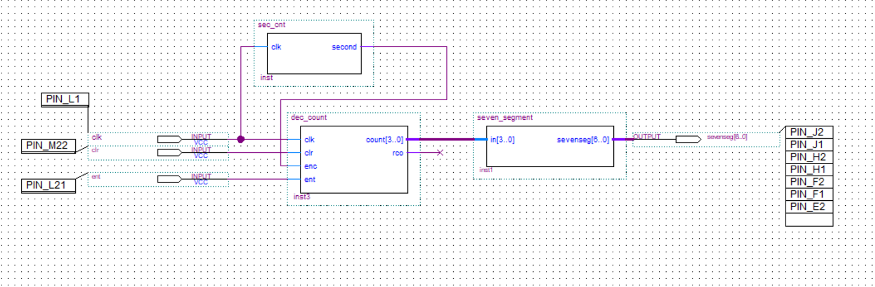

*Figure 14: Schematic circuit*

*Comment/Explanation:*

The circuit contains one more component with the symbol “sec_cnt”. The component is used to decide how many number the circuit count per second. According to the Verilog file, this component is particularly used to decide how many periods can circuit count for one time.

**Section 3.2 continues on the next page**

(1) The simulation waveform and its explanation  **[4 Marks]**

*Focused screenshot:*

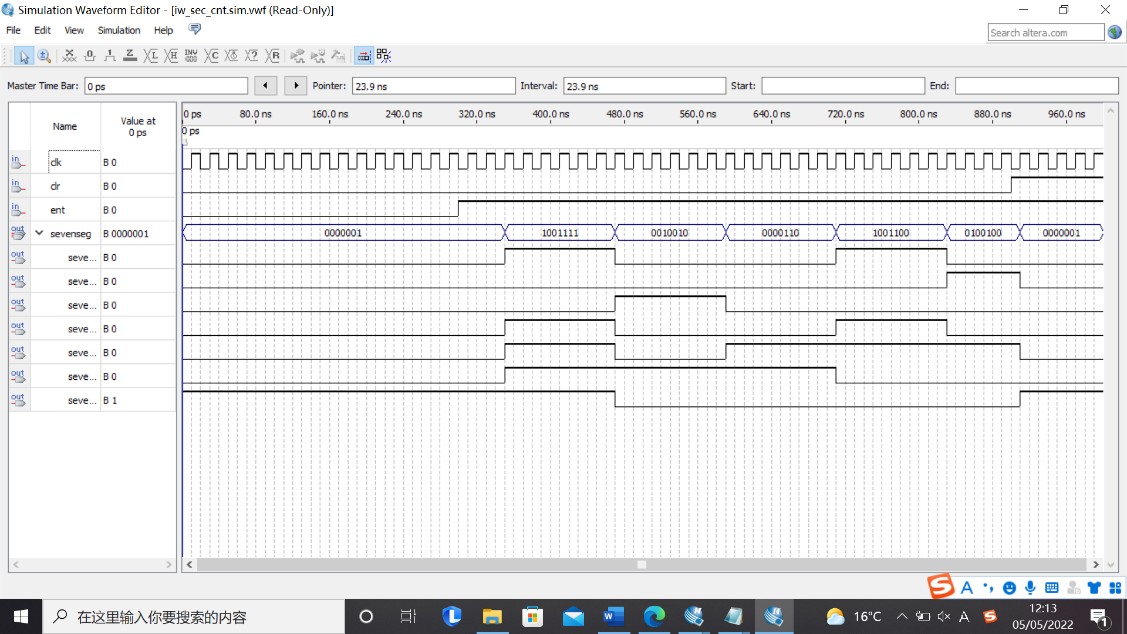

*Figure 15: Output waveform*

*Comment/Explanation:*

From the waveform, it can be seen that the counter will count after 6 periods. When the ent is set to 0. The output will not change. When clr is set to 1, the output will always be 0.

(2, 3) The schematic and simulation of the divide-by-12, and of

the cascading of two divide-by-12 counters  **[10 Marks]**

*Divide-by-12* ***code*** *– paste here as text (since the schematic would be just the same as the previous one)*

*module dec_count (output reg[3:0] count, output rco, input clk, clr, enc, ent);*

*assign rco = ((count == 4'd11) && ent);*

*always @ (posedge clk)*

*begin*

*if (clr) // If clr = 1,*

*count <= 0; // reset ‘count’ to zero.*

*else if (enc && ent && count != 4'd11) // Else, if enc & ent = 1,*

*// and count isn’t 11,*

*count <= count + 1; // increment count by 1*

*else if (enc && ent && count == 4'd11) // Else, if both enables*

*// are true, and count = 11,*

*count <= 0; // return count to 0.*

*else // Else (if one or both enables false),*

*count <= count; // do NOT increment.*

*end*

*endmodule*

*Divide-by-12 simulation – focused screenshot:*

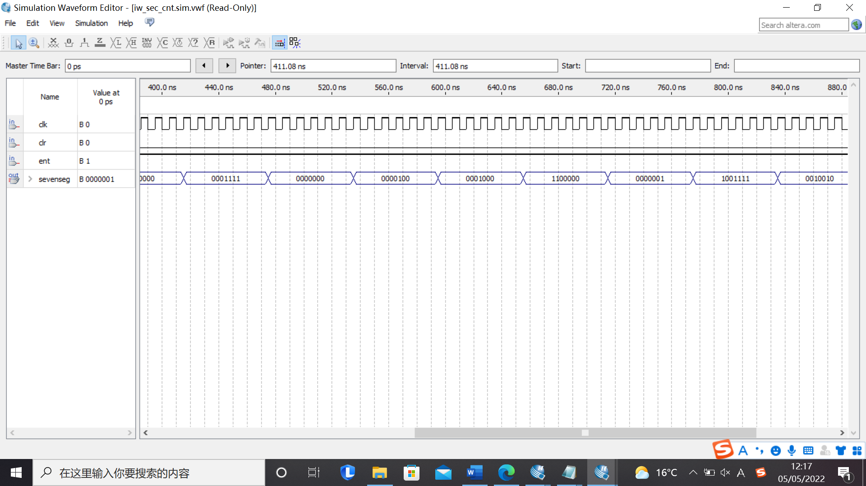

*Figure 16: Simulation result*

*Comment/Explanation for both:*

It can be seen that the counter counts to a maximum number of 12 (B in hexadecimal). Other rules are similar to Figure 15.

**Screenshots of cascading (schematic design):**

*Cascading schematic – focused screenshot:*

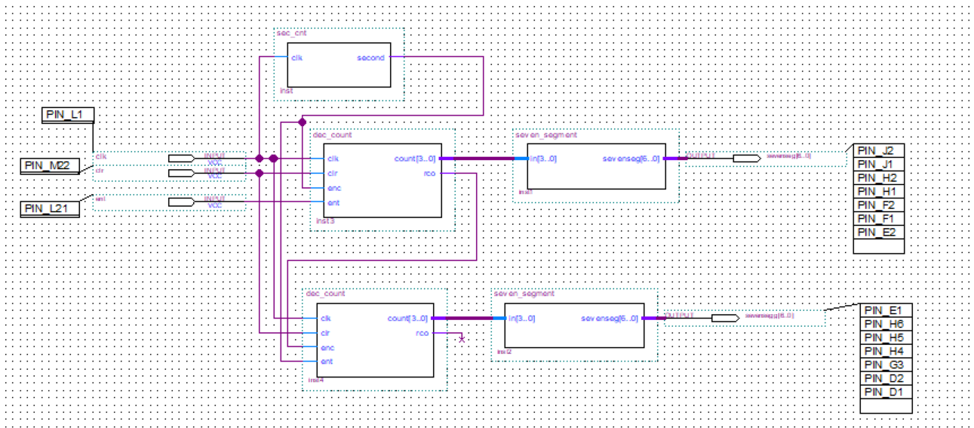

*Figure 17: Cascade system*

*Cascading simulation – focused screenshot:*

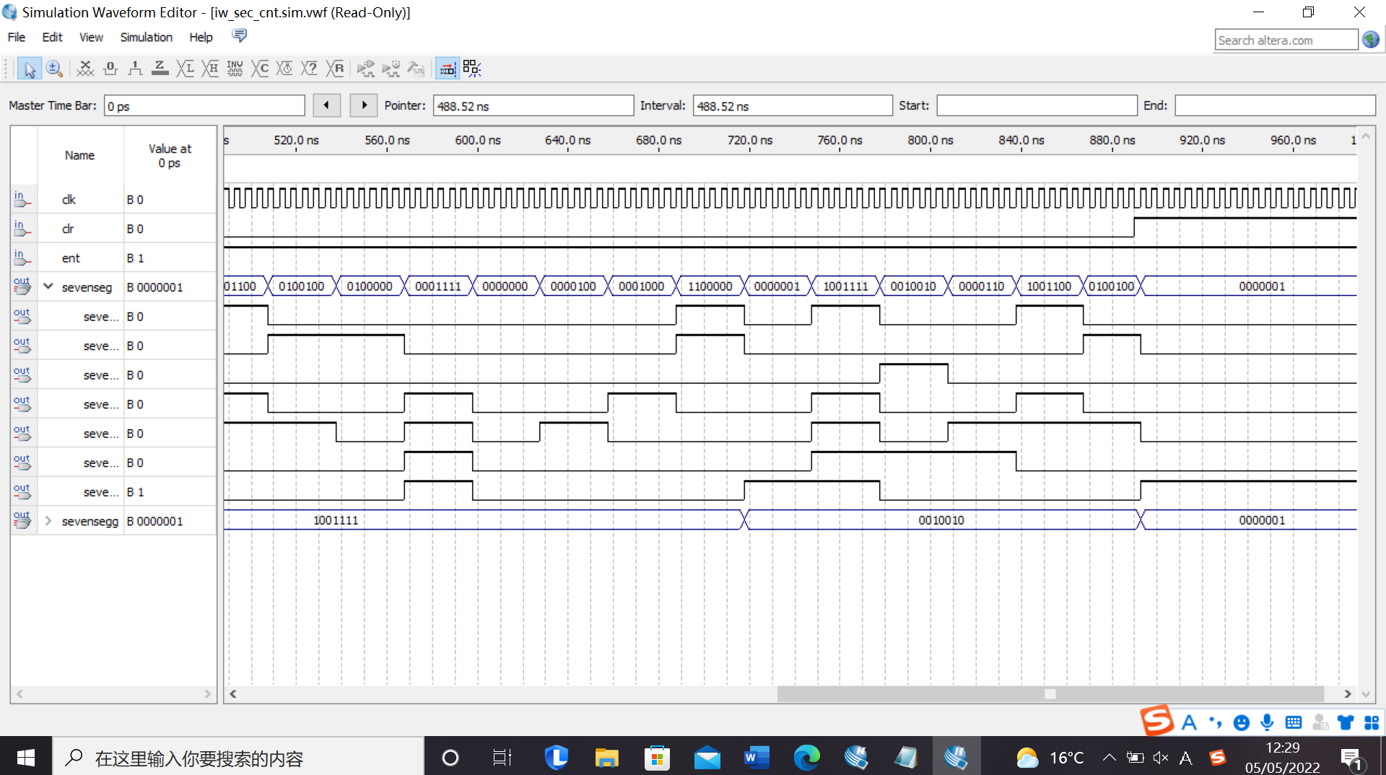

*Figure 18: Output waveform*

*Comment/Explanation for both:*

The system also follows the rules as discussed before. When the first counter counts to 12(10). The second counter will be activated.

The reason is that “rco” will be set to 1 when the first counter count to 12(10). This pin is connected to the “ent” of the second counter. Therefore, the second counter will be activated and start to count.

In this way, the total number this counter counts will be 12*12 = 144. (00 - BB in Hexadecimal).

**Photos of operation on the board**

Use this space to insert photographs of the DE1 board’s operation in the lab for the **three** parts of Section 3.2 of the script that instructed you to program the board.(You run the risk that some marks will be deducted from this section if such photographs are not included.)

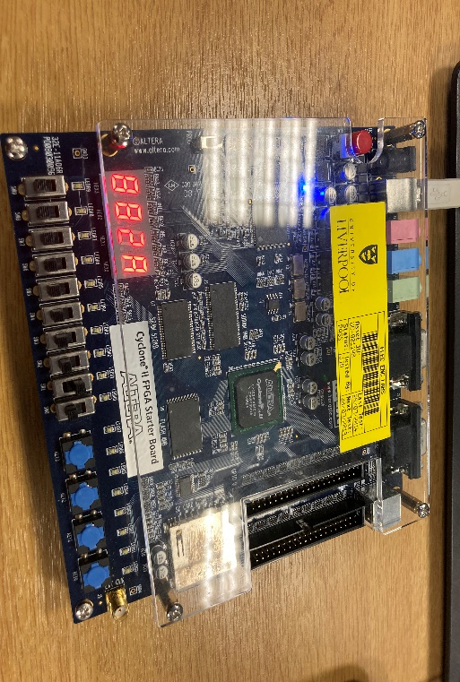

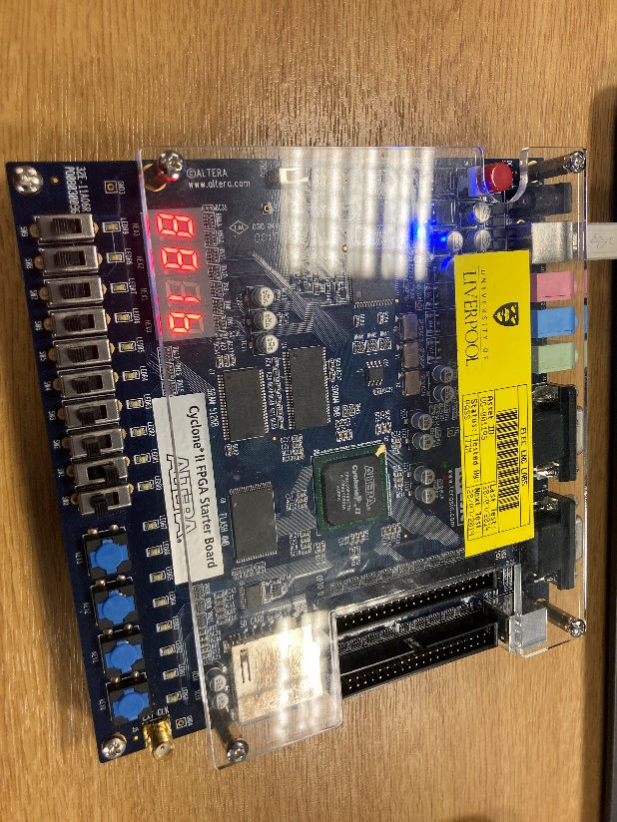

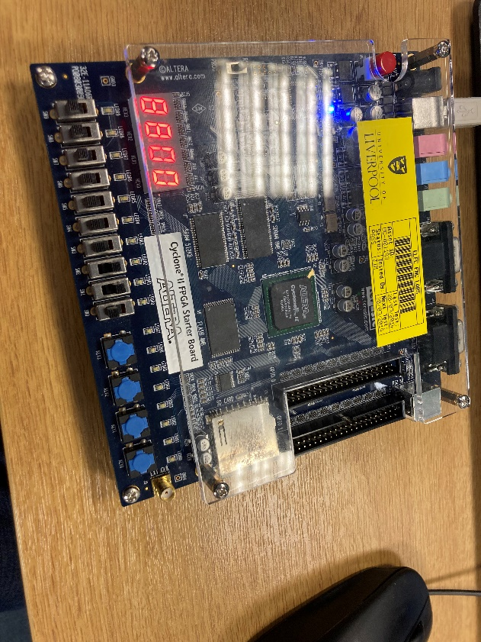

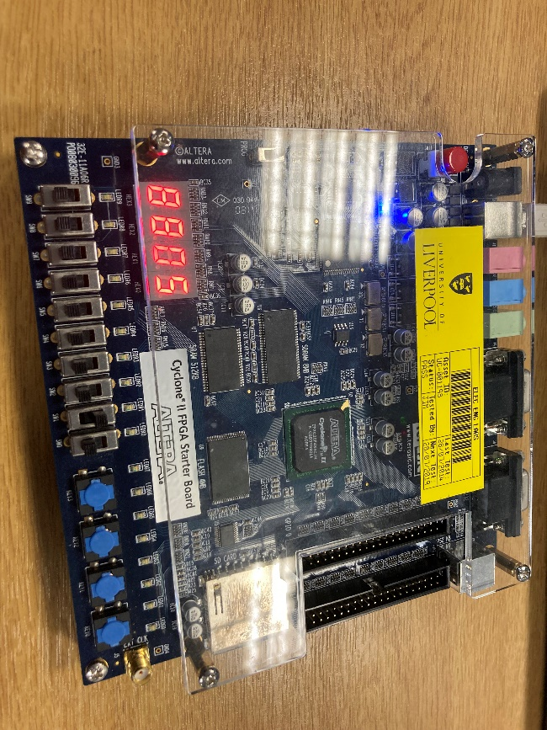

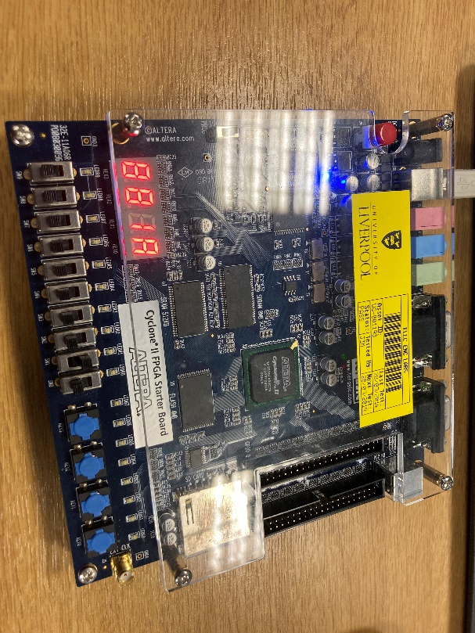

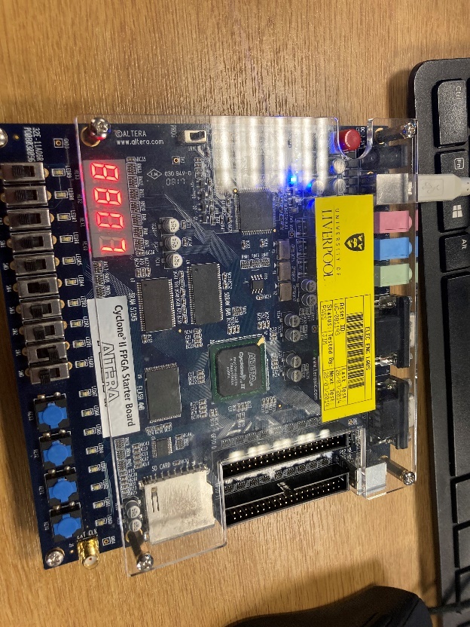

**See below for Section 4**

**Section 4. Design Assignments [30 Marks]**

**Section 4.1 Single Pulser [10 Marks]**

The Verilog code and annotated simulation

*The Verilog code (as text):*

*module signle_pulser (output reg out, input clk, reset, z);*

*localparam [1:0] // 3 states are required for Moore*

*s0 = 2'b00,*

*s1 = 2'b01,*

*s2 = 2'b10;*

*reg[1:0] state_reg, state_next;*

*reg p_out, cmd_1;*

*always @(posedge clk, posedge reset)*

*if (reset == 1) state_reg <= s0;*

*else*

*begin*

*state_reg <= state_next;*

*out = p_out;*

*end*

*// Moore Design*

*always @(state_reg, z)*

*begin*

*state_next = state_reg;*

*cmd_1 = 0;*

*case(state_reg)*

*s0: // if state is s0,*

*begin*

*p_out = 0;*

*cmd_1 = 0;*

*if(!z) // and z is 0*

*state_next = s1; // then go to s1*

*else*

*state_next = s0;*

*end*

*s1:*

*begin*

*p_out = 1;*

*cmd_1 = 0;*

*if(!z) // if z is 0,*

*state_next = s2; // go to s2,*

*else*

*state_next = s0; // else go to s0.*

*end*

*s2:*

*begin*

*p_out = 0;*

*cmd_1 = 0;*

*if(!z) // if z is 0,*

*state_next = s2; // then stay s2.*

*else*

*state_next = s0;*

*end*

*endcase*

*end*

*endmodule*

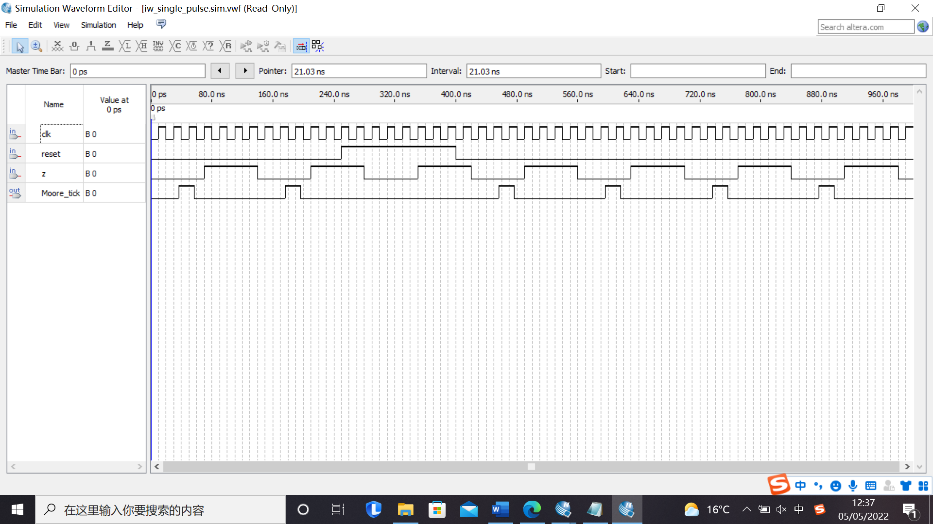*Simulation – focused screenshot:*

*Figure 19: Simulation result*

***Notice：It is an active low generate according to the supporting material. When the button is pressed, the “z” will be 0 and the circuit will work.***

*Comment/Explanation:*

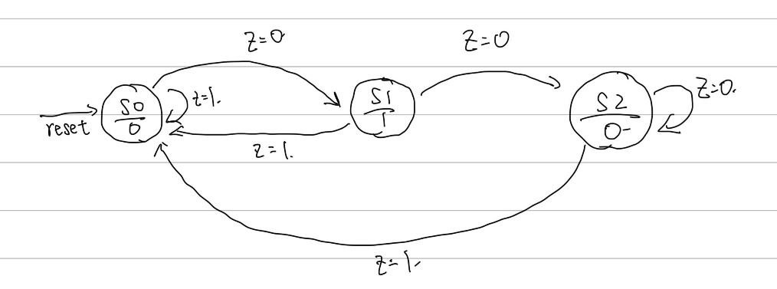The code is designed based on Figure 20.

Figure 20: State machine

When the button is pressed, the switch generates a low-level voltage and move the next state (for S2 stays at the same position). Otherwise, it will go back to S0.

From the simulation waveform, it can be seen that single pulse is raising edge triggered. If the button was pressed more than one period, a one-period single pulse will be generated. When the reset is high, the machine will back to S0. A small time delay can also be found at the raising edge of the pulse signal.

For, the 20ns clock cycle, if the input pulse period was decreased to less than 1 period, it can be seen that the pulse will not strictly follow the Moore machine rules. It can be seen in Figure 19. When input pulse period continues to decrease, there will be less pulse generate. It can be found that the pulse will appear at the start of the simulation or reset setting from 1 to 0.

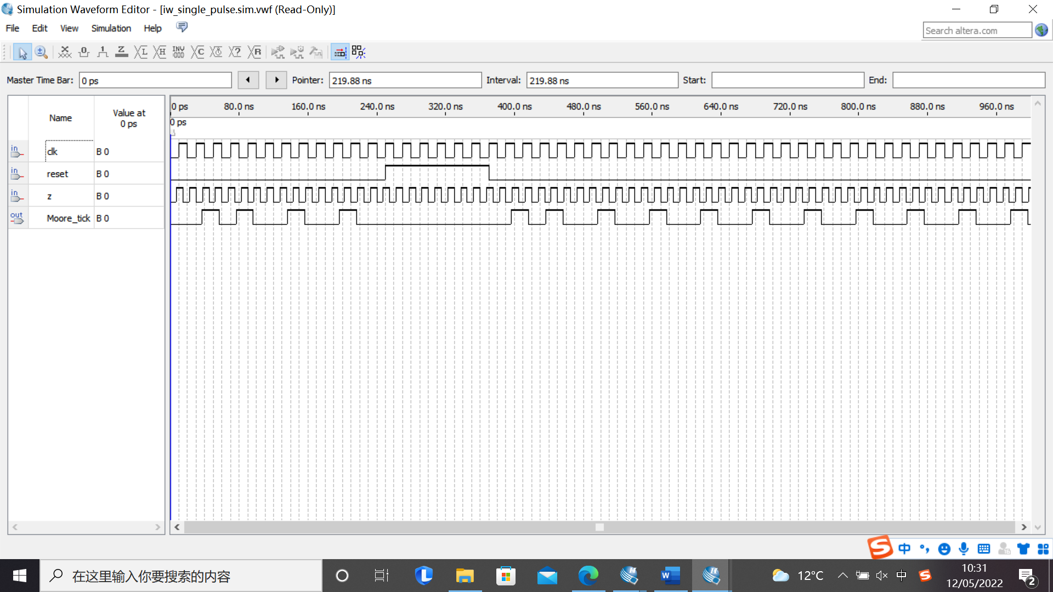

Figure 21: State machine (z = 13ns)

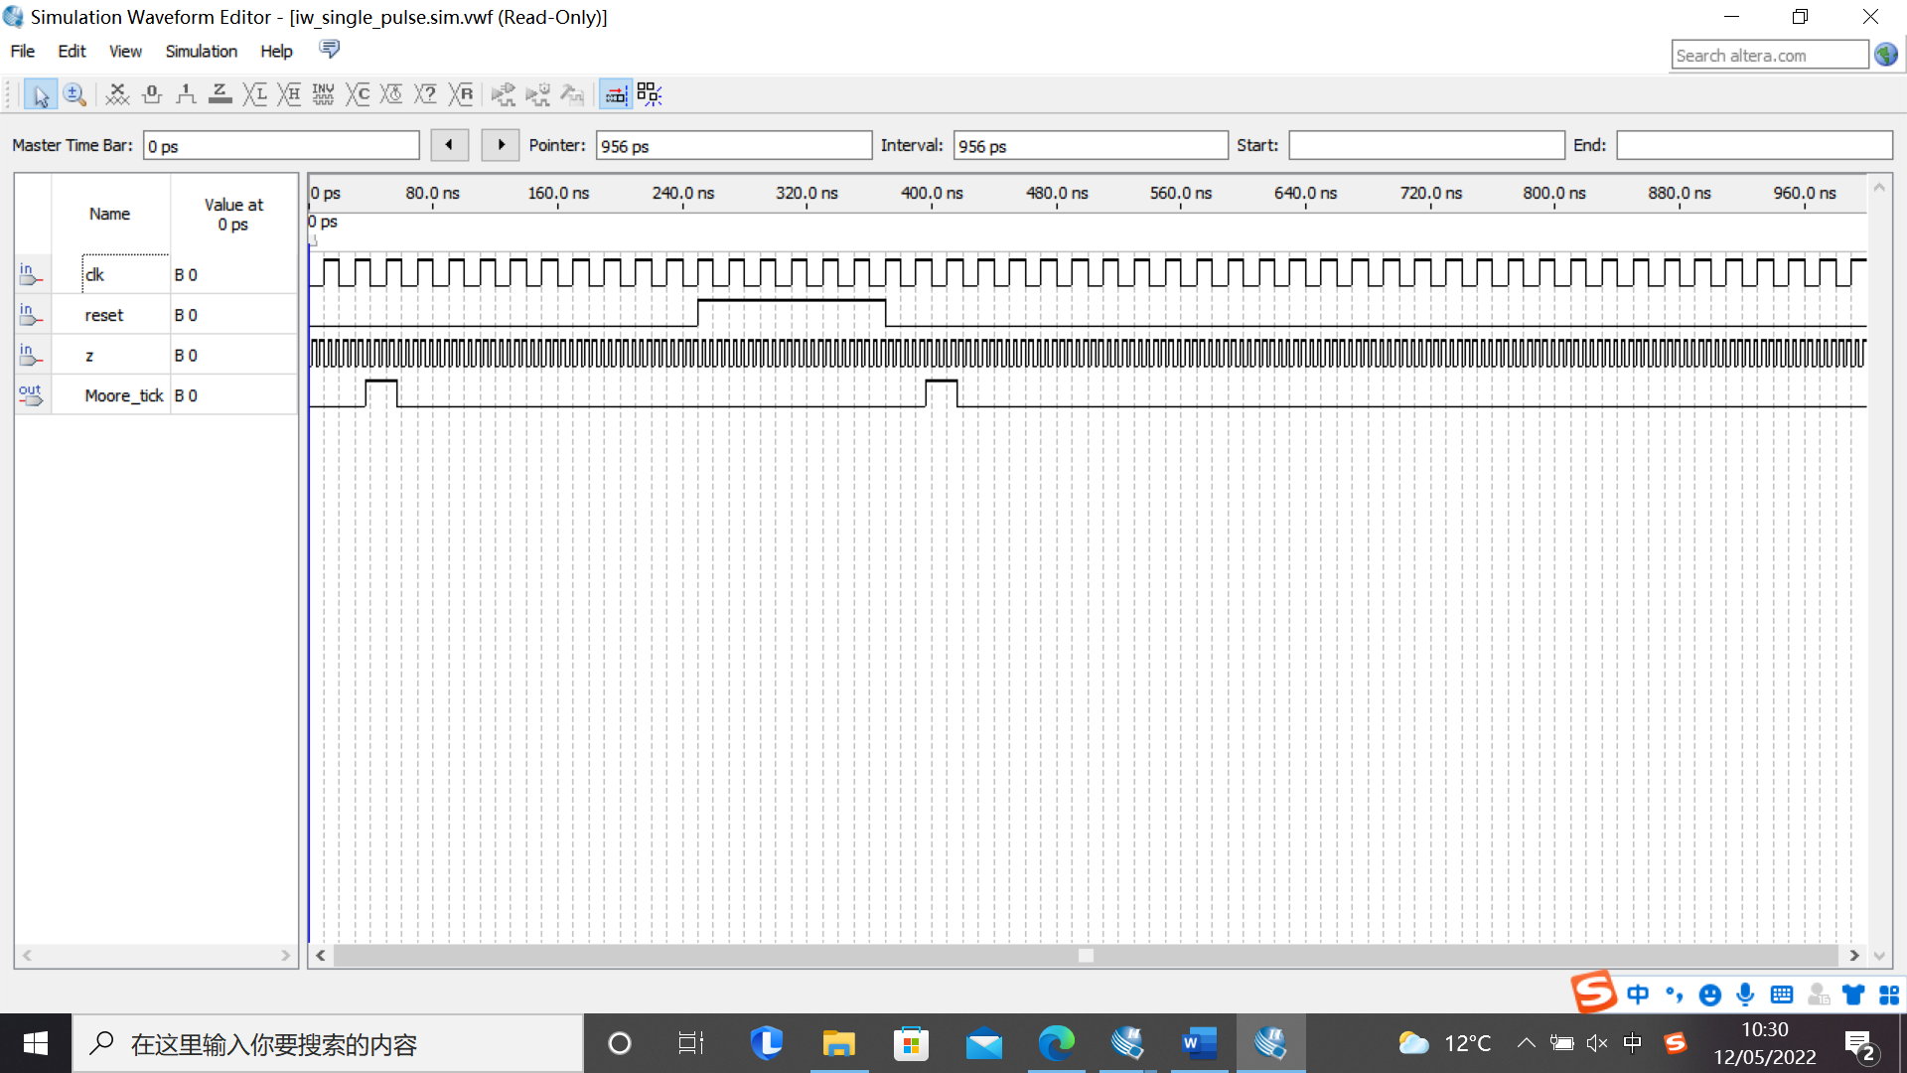

Figure 22: State machine (z = 5ns)

**Section 4.2 Pushbutton Enabled Counter [10 Marks]**

The schematic design (with pin assignments) and annotated simulation

*Schematic with pin assignments – focused screenshot:*

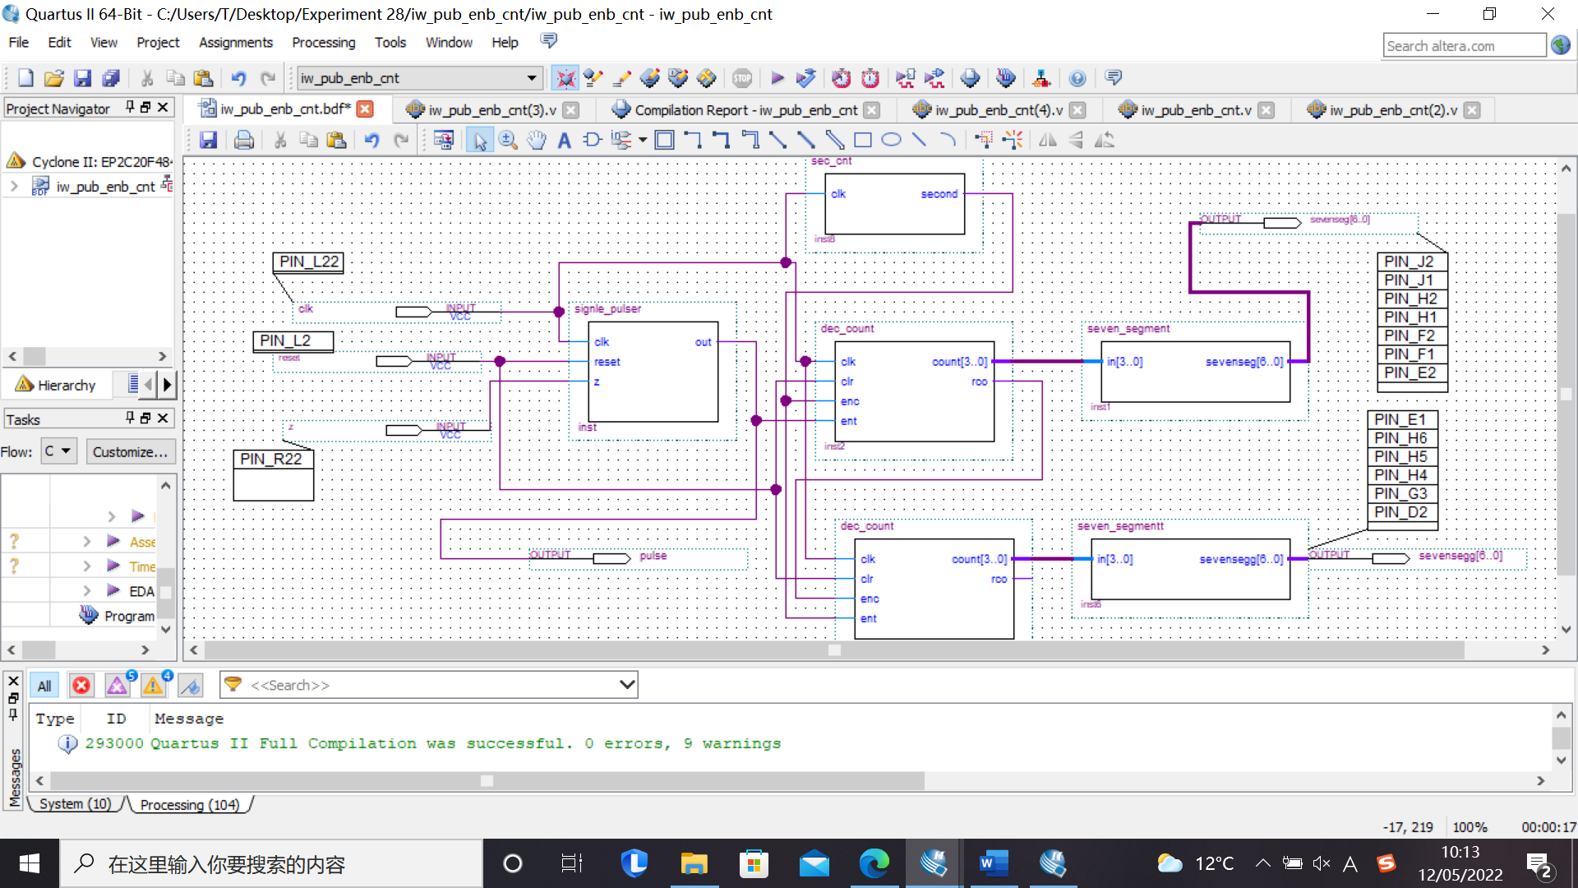

*Figure 23: Schematic design*

*Annotated simulation – focused screenshot:*

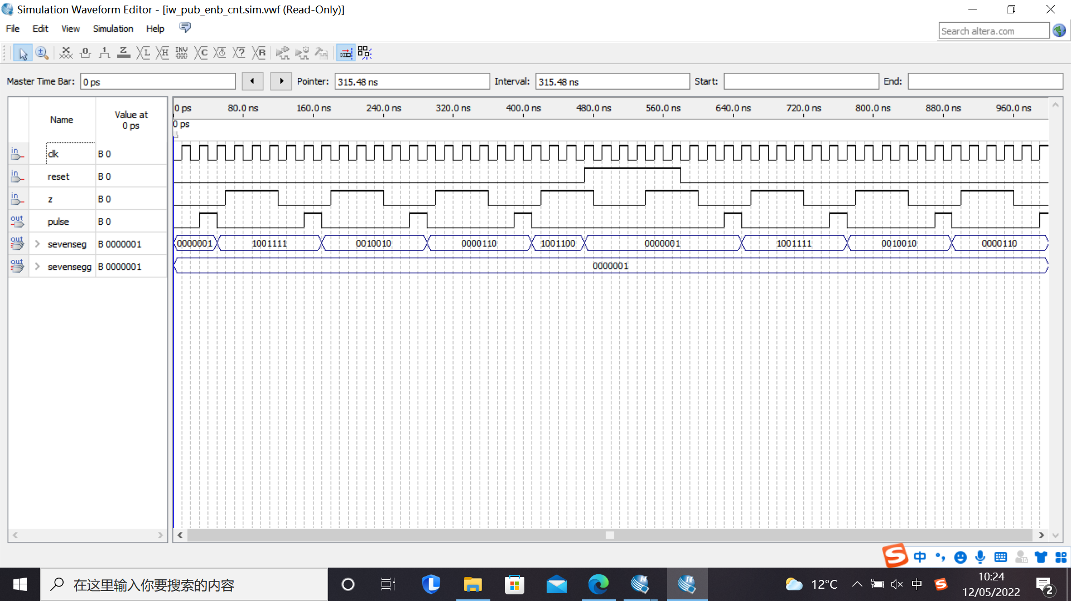

*Figure 24: Simulation waveform*

*Comment/Explanation for both:*

The last digit is 610. Therefore, the binary number is 110(2) and the switch is KEY[0]. The pin is PIN R_22.

This circuit contains three components: single pulse generator, counter and 7 segment display. These components follow rules that has been discussed in the previous section. The clock signal is shared by both pulse generator and counter. Thus, they can work synchronously. What is more, the reset pin and clear pin are also connected together. When a logic HIGH is at the input, the counter will stop working.

From the simulation graph, it can be seen that waveform is raising edge triggered. When the button is pressed, the pulse will be generated at the next clock cycle. Then, the counter will start to count after the pulse is generated. When the first counter counts to 9(10), the rco will become 1. Thus, the second counter will start to count.

**Section 4.3 Adder/Subtractor Logic Design [10 Marks]**

The schematic design (with pin assignments) and annotated simulation

*Schematic with pin assignments – focused screenshot:*

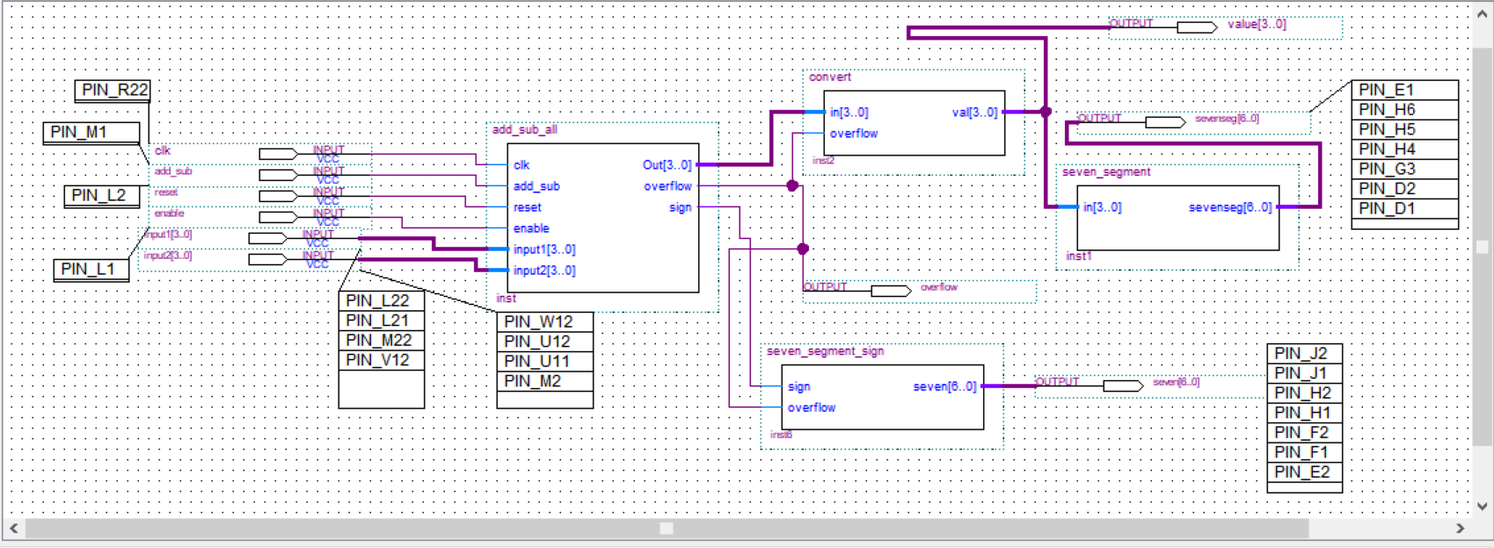

*Figure 25: Schematic design*

*Include here the Verilog code (as text) if you produced it in Verilog – or an explanation of how you built the schematic, step by step, if you did not produce it in Verilog:*

*module add_sub_all(*

*output reg[3:0] Out,*

*output reg overflow, sign,*

*input clk, add_sub, reset, enable,*

*input [3:0] input1, input [3:0] input2);*

*reg sign_1, sign_2;*

*reg[3:0] num_1,num_2;*

*reg o_overflow, o_sign;*

*reg[3:0] o_value;*

*always @(posedge clk, posedge reset)*

*begin*

*if(reset)//reset = 1*

*begin*

*Out = 4'b0;*

*overflow = 0;*

*sign = 0;*

*end*

*else //reset = 0*

*begin*

*if(enable) //enable = 1;*

*begin*

*Out = o_value;*

*overflow = o_overflow;*

*sign = o_sign;*

*end*

*end*

*end*

*always@(add_sub, input1 ,input2)*

*begin*

*if (input1[3])//judging input value*

*begin*

*num_1 = (~input1)+4'b1;*

*sign_1 = 1;*

*end*

*else*

*begin*

*num_1 = input1;*

*sign_1 = 0;*

*end*

*if (input2[3])*

*begin*

*num_2 = (~input2)+4'b1;*

*sign_2 = 1;*

*end*

*else*

*begin*

*num_2 = input2;*

*sign_2 = 0;*

*end*

*if(add_sub) //subtraction*

*begin*

*if((sign_1==0)&&(sign_2==1))//+-*

*begin*

*o_value = num_1+num_2;*

*o_sign = 0;*

*end*

*else if((sign_1==1)&&(sign_2==0))//-+*

*begin*

*o_value = num_1+num_2;*

*o_sign = 1;*

*end*

*else if((sign_1==0)&&(sign_2==0))//++*

*begin*

*if (num_1<num_2)*

*begin*

*o_value = num_2-num_1;*

*o_sign = 1;*

*end*

*else //num_1>num_2*

*begin*

*o_value = num_1 - num_2;*

*o_sign = 0;*

*end*

*end*

*else //--*

*begin*

*if(num_1>num_2)*

*begin*

*o_value = num_1-num_2;*

*o_sign = 1;*

*end*

*else//num_1>num_2*

*begin*

*o_value = num_2-num_1;*

*o_sign = 0;*

*end*

*end*

*end*

*else//add_sub add*

*begin*

*if ((sign_1==0)&&(sign_2==1))//+-*

*begin*

*if(num_1>num_2)*

*begin*

*o_value = num_1-num_2;*

*o_sign = 0;*

*end*

*else //num_1<num_2*

*begin*

*o_value = num_2-num_1;*

*o_sign = 1;*

*end*

*end*

*else if((sign_2==0)&&(sign_1==0))//++*

*begin*

*o_value = num_1 + num_2;*

*begin*

*if (o_value>4'b1000)*

*begin*

*o_sign = 1;*

*end*

*else*

*begin*

*o_sign = 0;*

*end*

*end*

*end*

*else if ((sign_1==1)&&(sign_2==0))//-+*

*begin*

*if(num_1>num_2)*

*begin*

*o_value = num_1-num_2;*

*o_sign = 1;*

*end*

*else//num1<num2*

*begin*

*o_value = num_2 - num_1;*

*o_sign = 0;*

*end*

*end*

*else if ((sign_1==0)&&(sign_2==1))//+-*

*begin*

*if(num_1<num_2)*

*begin*

*o_value = num_2-num_1;*

*o_sign = 1;*

*end*

*else //num1>num2*

*begin*

*o_value = num_1-num_2;*

*o_sign = 0;*

*end*

*end*

*else//--*

*begin*

*o_value = num_1+num_2;*

*o_sign = 1;*

*end*

*end*

*if (o_sign)//sign:-*

*begin*

*if (o_value>4'b1000)*

*begin*

*o_overflow = 1;*

*end*

*else//-8< output <0*

*begin*

*o_overflow = 0;*

*end*

*end*

*else//sign:+*

*begin*

*if (o_value<4'b1000)*

*begin*

*o_overflow = 0;*

*end*

*else*

*begin*

*o_overflow = 1;*

*end*

*end*

*end*

*endmodule*

*module convert(output reg[3:0] val, input [3:0] in, input overflow);*

*always@(in,overflow)*

*begin*

*if (overflow)*

*val = 4'b0000;*

*else*

*begin*

*if (in[3])//judging input value*

*begin*

*val = (~in)+4'b1;*

*end*

*else*

*begin*

*val = in;*

*end*

*end*

*end*

*endmodule*

*// -a-*

*// f| |b*

*// -g-*

*// e| |c*

*// -d-*

*//*

*// 0 1 2 3 4 5 6 7 8 9 A B C D E F*

*module seven_segment_sign (output reg[6:0] seven, input sign,overflow);*

*always @(sign,overflow)*

*begin*

*if (overflow)*

*begin*

*seven = 7'b1111111;*

*end*

*else*

*begin*

*if (sign)*

*begin*

*seven = 7'b1111110;*

*end*

*else*

*begin*

*seven = 7'b1111111;*

*end*

*end*

*end*

*endmodule*

*// -a-*

*// f| |b*

*// -g-*

*// e| |c*

*// -d-*

*//*

*// 0 1 2 3 4 5 6 7 8 9 A B C D E F*

*module seven_segment (output reg[6:0] sevenseg, input [3:0] in);*

*always @(in)*

*begin*

*case(in)*

*//abcd*

*4'h0: sevenseg = 7'b0000001;*

*4'h1: sevenseg = 7'b1001111;*

*4'h2: sevenseg = 7'b0010010;*

*4'h3: sevenseg = 7'b0000110;*

*4'h4: sevenseg = 7'b1001100;*

*4'h5: sevenseg = 7'b0100100;*

*4'h6: sevenseg = 7'b0100000;*

*4'h7: sevenseg = 7'b0001111;*

*4'h8: sevenseg = 7'b0000000;*

*4'h9: sevenseg = 7'b0000100;*

*4'hA: sevenseg = 7'b0001000;*

*4'hB: sevenseg = 7'b1100000;*

*4'hC: sevenseg = 7'b0110001;*

*4'hD: sevenseg = 7'b1000010;*

*4'hE: sevenseg = 7'b0110000;*

*4'hF: sevenseg = 7'b0111000;*

*endcase*

*end*

*endmodule*

*Annotated simulation – focused screenshot:*

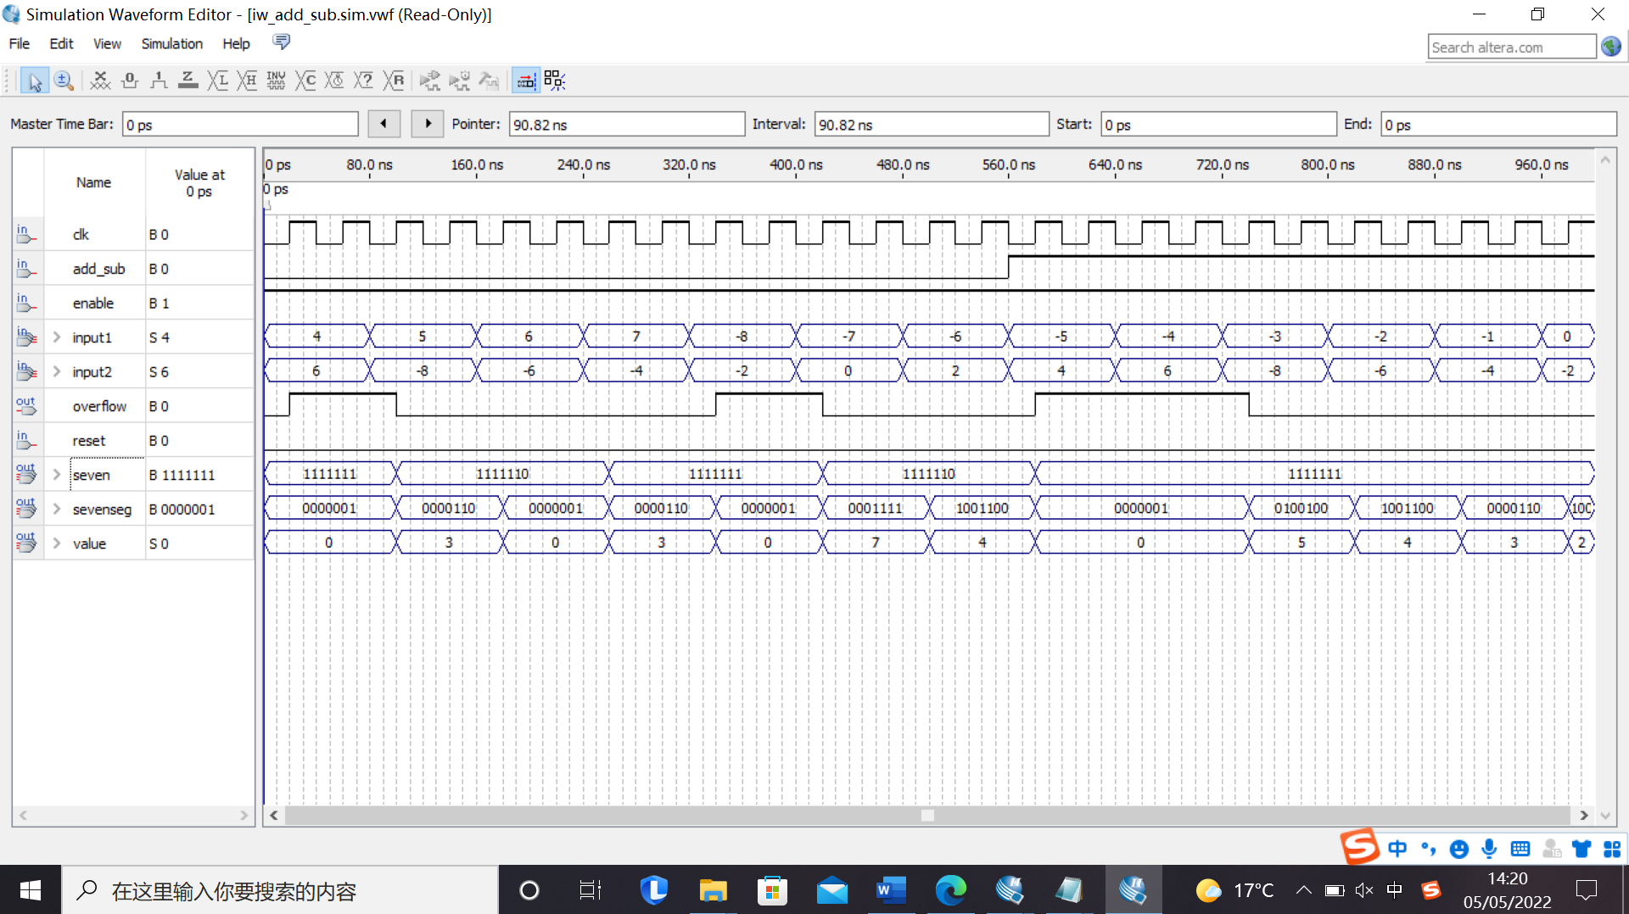

*Figure 26: Output waveform*

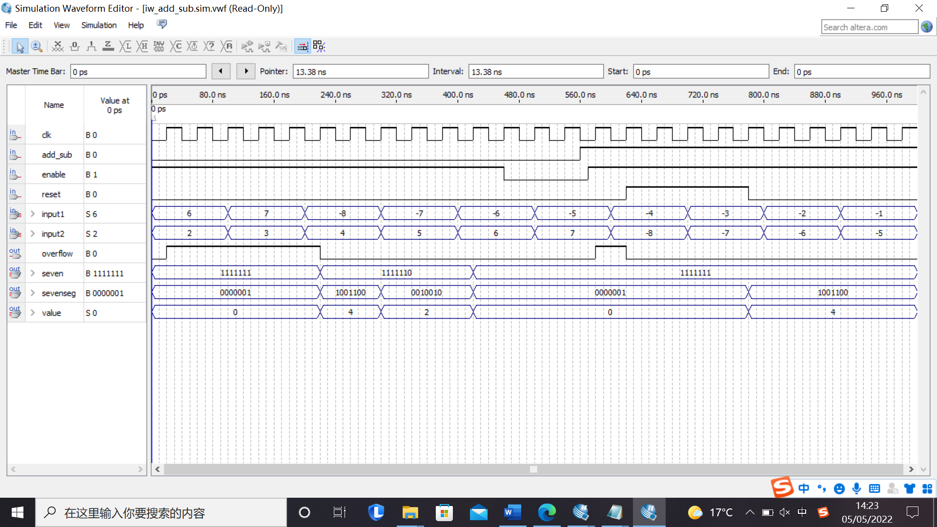

*Figure 27: Output waveform*

*Comment/Explanation for both:*

From Figure 25, it can be seen that the circuit contains contain four components: the combination of adder and subtractor, inverter and two seven segment display.

add_sub_all has two inputs represent two input numbers from -8(10) to 7(10) in binary. Enable, clock and reset inputs are used to control the process of the calculation. The effect of these pins can be seen in Figure 26 and 27. The add_sub pin is used to change the calculation format: add or subtraction. When the add_sub sets to low, it operates add calculation.

The convert component is used to output the magnitude of the number and sends the number to the 7-segment decoder to display the value. The overflow will be used to judge whether the number is out of the range. If it out of range, the output will be zero.

For the lower segment, it is used to show the sign of the number, which is controlled by “sign” and “overflow”. “11111111” means positive, while “11111110” means negative. It can be seen in the simulation process. When the overflow is set, there will be no sign.

**See below for Appendix of full-screen screenshots.**

**Appendix**

**Important**: dump here all the **full-screen screenshot versions** of your focused screenshots used above, including the taskbar with date and time, and initialled filename(s) and relevant windows. (See instructions and rationale on main experiment script p.2.)

